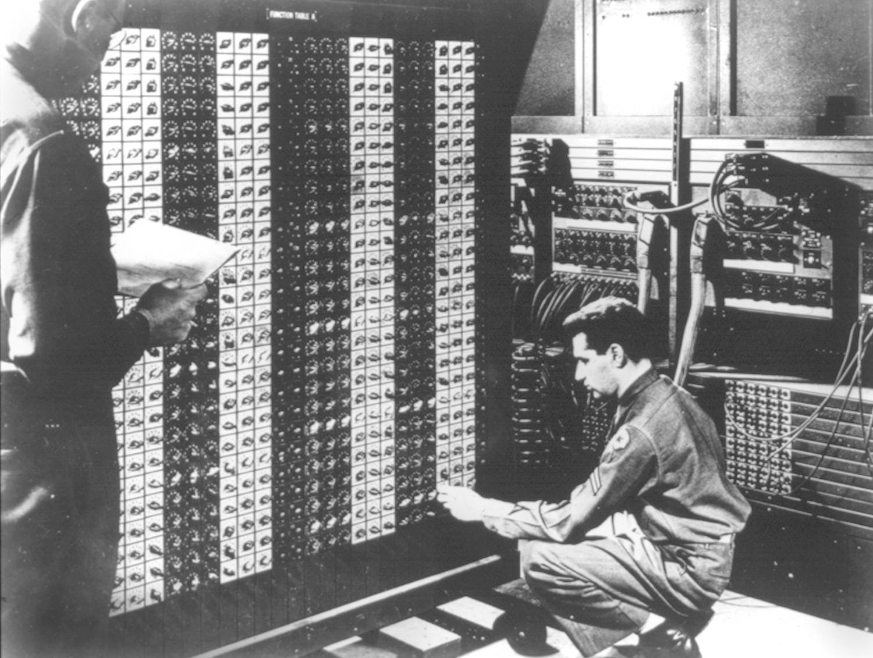
Advanced Placement Computer Science
Unit 1: Number Systems, Wrappers, DM Law
Lesson: Class Location and Classpath
Last Updated: 9/11/2015

When working in java, there are several classes that ship as part of the java development kit or JDK.
Each one has a directory that it is organized within.

Core packages in Java SE 6[edit]
Main article: Java Platform, Standard Edition
java.lang | — basic language functionality and fundamental types
java.util | — collection data structure classes
java.io | — file operations
java.math | — multiprecision arithmetics
java.nio | — the New I/O framework for Java
java.net | — networking operations, sockets, DNS lookups, ...
java.security | — key generation, encryption and decryption
java.sql | — Java Database Connectivity (JDBC) to access databases
java.awt | — basic hierarchy of packages for native GUI components
javax.swing | — hierarchy of packages for platform-independent rich GUI components
java.applet | — classes for creating an applet

- Classes inside java.lang do not need to be imported
These include Math, Integer, System,
- Classes outside this package need imports or full names
import java.util.Scanner; //java.util.Scanner s = new java.util.Scanner(System.in);
- User defined classes can be used in same project
Otherwise you must put your class in the classpath

