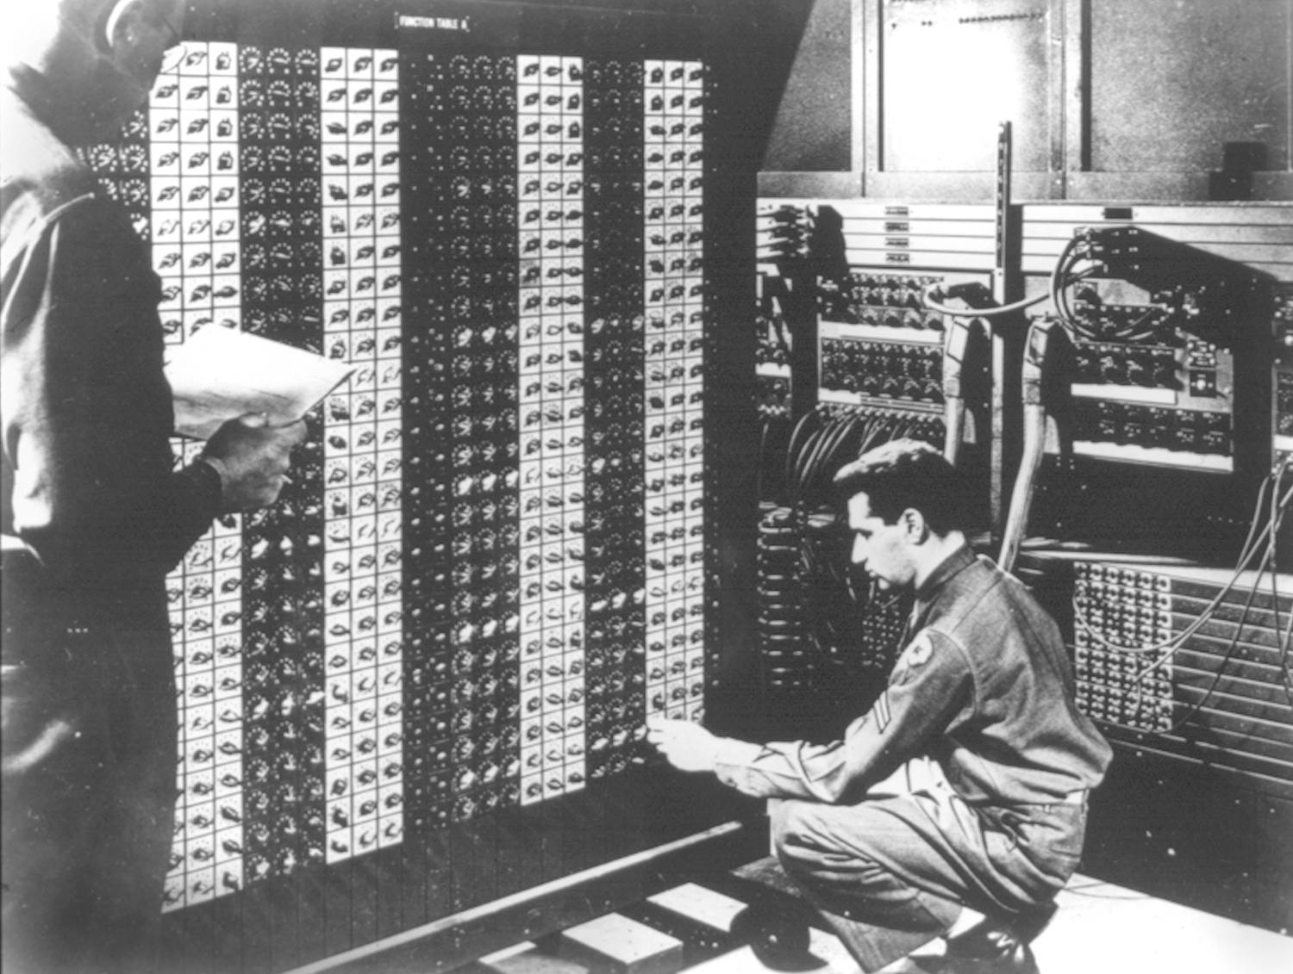
Advanced Placement Computer Science
Shenendehowa HS mr Hanley
Unit 4: Object Oriented ProgrammingFILLED_OUT
Lesson: Advanced Features Ver 3.0
Last Updated: 11/13/2017

Lesson: Parameter Passing Mechanisms
Last Updated: 100/11001/1100

In addition to writing classes using private variables and public accessors and mutators, here are 3 common features that are built into classes.

- Exception Handling: A way of responding to error conditions
In your class, add the statement throws with a type of Exception
In your client, add a try catch block
java will search for a try catch block in previously called methods

- static or class variables:
variables SHARED by all instances of the class

- public String toString()
represents object as a single string
Useful for debugging!!!!
/**
* ---------------------------------------------------------------------------
* S-h-e-n-e-n-d-e-h-o-w-a--H-i-g-h--S-c-h-o-o-l--T-e-c-h-n-o-l-o-g-y--D-e-p-t
* ---------------------------------------------------------------------------
* FILE: RectangleV2.java
* DATE: 11/23/2013
* PURPOSE: Demonstrate the Comparable interface, toString, static
* variables and exception handling
* @author mr Hanley
* @version 1.0
* ----------------------------------------------------------------------------
* h-a-n-l-e-y.c-o-.-n-r------t-e-a-m-2-0-.-c-o-m------------------------------
*/
import java.awt.Color;
import java.awt.Graphics;

public class RectangleV2 implements Comparable {
//++++++++++++++++++++++++++++++++++++++++++++++++++++++++++++++++
//++++++++++++ S T A T I C V A R I A B L E S ++++++++++++++++
//++++++++++++++++++++++++++++++++++++++++++++++++++++++++++++++++
public static int rectCount = 0;//Yo yo yo, this is SHARED BY ALL //RECTANGLESV2
//----------------------------------------------------------------
//---------------- I N S T A N C E V A R I A B L E S ------------
//----------------------------------------------------------------
private int x, y, width, height, rotation; //rotation is 0 deg
private Color outCol, fillColl;
private boolean filled;
private FillType ft;

//////////////////////////////////////////////////////////////////
//////// C O N S T R U C T O R S ///////////////////////
//////////////////////////////////////////////////////////////////
public RectangleV2() {
x = y = 0;
width = 50;
height = 25;
outCol = Color.BLACK;
fillColl = Color.CYAN;
filled = true;
ft = FillType.solid;
rectCount++;
}
public RectangleV2(Color outColIn, Color fillCollIn) {
x = y = 0;
width = 50;
height = 25;
outCol = outColIn;
fillColl = fillCollIn;
filled = true;
ft = FillType.solid;
rectCount++;
}

public RectangleV2(int xIn, int yIn, int w, int h) {
x = xIn;
y = yIn;

width = w;
height = h;
outCol = Color.black;
fillColl = Color.MAGENTA;
filled = true;
ft = FillType.solid;
rectCount++;
}

//AAAAAAAAAAAAAAAAAAAAAAAAAAAAAAAAAAAAAAAAAAAAAAAAAAAAAAAAAAAAAAAAA
//AAAAAAAAAAAAAAA A C C E S S O R S AAAAAAAAAAAAAAAAAAAAAAAAAAAAA
//AAAAAAAAAAAAAAAAAAAAAAAAAAAAAAAAAAAAAAAAAAAAAAAAAAAAAAAAAAAAAAAAA
//Compareto is based on position, row major
public int compareTo(Object other) {
Rectangle otherR = (Rectangle) other; //typecast
if (y != otherR.getY()) {
return y - otherR.getY();
}
//Else go to the column
return x - otherR.getX();
}

public int getX() {
return x;
}

public int getY() {
return y;
}

public int getW() {
return width;
}

public int getH() {
return height;
}

public Color getOutCol() {
return outCol;
}

public Color getFillCol() {
return fillColl;
}

public int getArea() {
return width * height;
}

public String toString() {
return "[" + x + "," + y + " Width = " + width + " Height = " + height + " Total number of rect= "+rectCount +"]";//Brian
}

public void draw(Graphics g) {
//Draw the first rectangle
//System.out.println("Here");
g.setColor(getOutCol());
//System.out.println("x = "+getX()+"width"+width);
g.drawRect(getX(), getY(), width, height);
g.setColor(getFillCol());
g.fillRect(getX() + 1, getY() + 1, width - 1, height - 1);
}

//MMMMMMMMMMMMMMMMMMMMMMMMMMMMMMMMMMMMMMMMMMMMM
//MMMMMMMMMMMMMMM M U T A T O R S MMMMMMMMMM
//MMMMMMMMMMMMMMMMMMMMMMMMMMMMMMMMMMMMMMMMMMMMM
public void setX(int inX) throws IllegalArgumentException {
if (inX < 0) {
throw new IllegalArgumentException("Bad x value of " + inX);
}
x = inX;
}
public void setY(int inY) {
y = inY;
}
public void setWidth(int w) {
width = w;
}
public void setHeight(int h) {
height = h;
}
}

