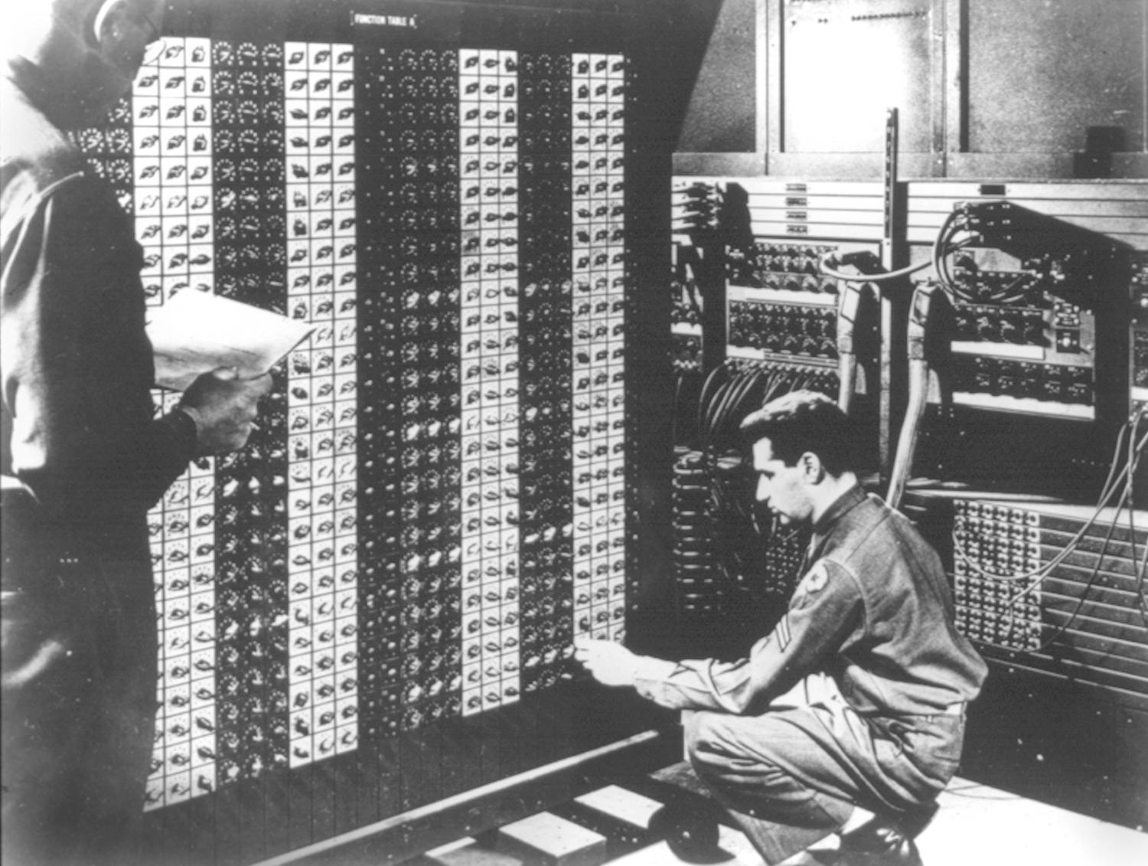
Advanced Placement Computer Science
Shenendehowa HS mr Hanley
Unit 4: Object Oriented Programming
Lesson: Interfaces
Last Updated: 11/12/2015

Lesson: Parameter Passing Mechanisms
Last Updated: 100/11001/1100

USB is really cool, isn’t it?
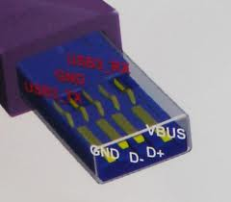 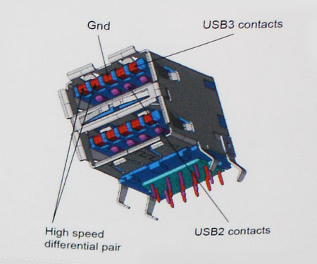
It allows us to plug a thumb drive into any computer that supports USB, and voila, after installing the device driver, you’ve got a removable drive!!!!

Java has a similar concept, interfaces are a collection of _____________________________________
Let’s look at a useful interface.
public interface MouseListener extends EventListener {
/**
* Invoked when the mouse button has been clicked (pressed
* and released) on a component.
*/
public void mouseClicked(MouseEvent e);
/**
* Invoked when a mouse button has been pressed on a component.
*/
public void mousePressed(MouseEvent e);
/**
* Invoked when a mouse button has been released on a component.
*/
public void mouseReleased(MouseEvent e);
/**
* Invoked when the mouse enters a component.
*/
public void mouseEntered(MouseEvent e);
/**
* Invoked when the mouse exits a component.
*/
public void mouseExited(MouseEvent e); }
All methods in an interface must be _____________________________________

Differences between interfaces and classes

Interfaces guarantee that certain methods are implemented. This helps write more general purpose code.
Some popular interfaces;
Interface | Methods that must be implemented
ActionListener | public void actionPerformed(ActionEvent blah)
Comparable | public int compareTo(Object o)
KeyListener | public void keyPressed (KeyEvent e)  public void keyTyped (KeyEvent e)  public void keyReleased (KeyEvent e)
MouseListener | public void mousePressed(MouseEvent event)  public void mouseClicked(MouseEvent event)  public void mouseReleased(MouseEvent event)  public void mouseEntered(MouseEvent event)  public void mouseExited(MouseEvent event)

Now if we create a class that implements BOTH MouseListener and KeyListener, what do we know?

public class MyFrame implements KeyListener, MouseListener {

}
How about the Comparable interface?
You must define how to __________________________________________________________________
Works like the mathematical operator ______________________________________________
For example, String implements Comparable, so
String s1 = “CAT”, s2 = “DAD”;
int result = s1.compareTo(s2); //what is the value of result???
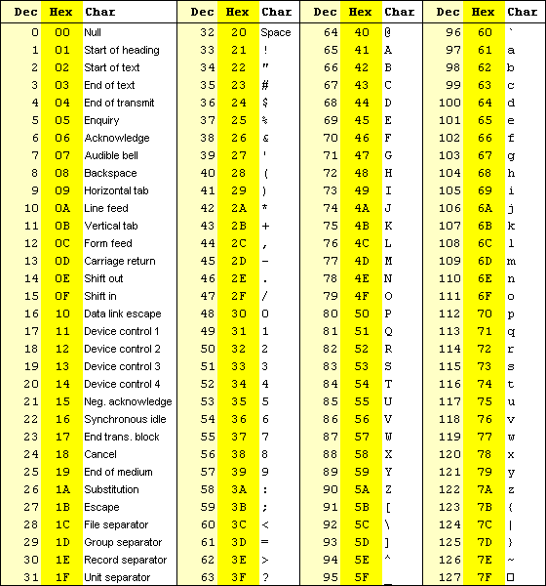
How about “Carly”.compareTo(“Allen”);
How about “Eric”.compareTo(“Erin”);
How about “Sanjee”.compareT0(“Sanjee”);
How about “tea”.compareTo(“teapot”);

How about “teapot”.compareTo(“tea”);

Summary:
What does this allow us to do with Strings?

Furthermore, there is a method _______________________________ which will sort any ArrayList of Comparables
ArrayList<String> namesAL = new ArrayList<String>();

namesAL.add("Cara");
namesAL.add("Carly");
namesAL.add("Bob");
namesAL.add("Austin");
namesAL.add("Zoe");
namesAL.add("Jessica");

Collections.sort(namesAL);
for (int i = 0; i < namesAL.size(); i++) {
System.out.println(namesAL.get(i));
}
//OUTPUT
Austin
Bob
Cara
Carly
Jessica
Zoe

How about a TennisPlayer class that implements Comparable?
import java.util.Date;

public class TennisPlayer implements Comparable {

private String lastName, firstName, countryOrigin;
private Date dob;
private int rank, annualEarnings, tourPoints;

public int getRank() { return rank; }

public int compareTo(Object other) {
TennisPlayer oth = (TennisPlayer) other; //must TYPECAST when using compareTo
return rank – oth.getRank();
}
}

How do we use this to test 2 players?
public class Tester {
public static void main(String args[]) {

TennisPlayer rafa = new TennisPlayer(“Nadal”, “Rafael”, “Espana”, new
Date(1986,6,3), 5, 583074, 6675);
TennisPlayer roger = new TennisPlayer(“Federer”, “Roger”, “Switzerland”, new
Date(1981,8,18), 3, 550017, 5205);
//Write the logic to compare the two players

}
}

Interfaces can also be passed as parameters to a method.
/**
* The <code>AudioClip</code> interface is a simple abstraction for playing a sound clip. Multiple
* <code>AudioClip</code> items can be playing at the same time, and the resulting sound is mixed together * to produce a composite.
* @author Arthur van Hoff
* @since JDK1.0
*/
public interface AudioClip {
/**
* Starts playing this audio clip. Each time this method is called,
* the clip is restarted from the beginning. */
void play();
/**
* Starts playing this audio clip in a loop. */
void loop();
/**
* Stops playing this audio clip.*/
void stop();
}
Write a method called playIntro that takes in an AudioClip (ac)reference and plays it as the intro to a program

