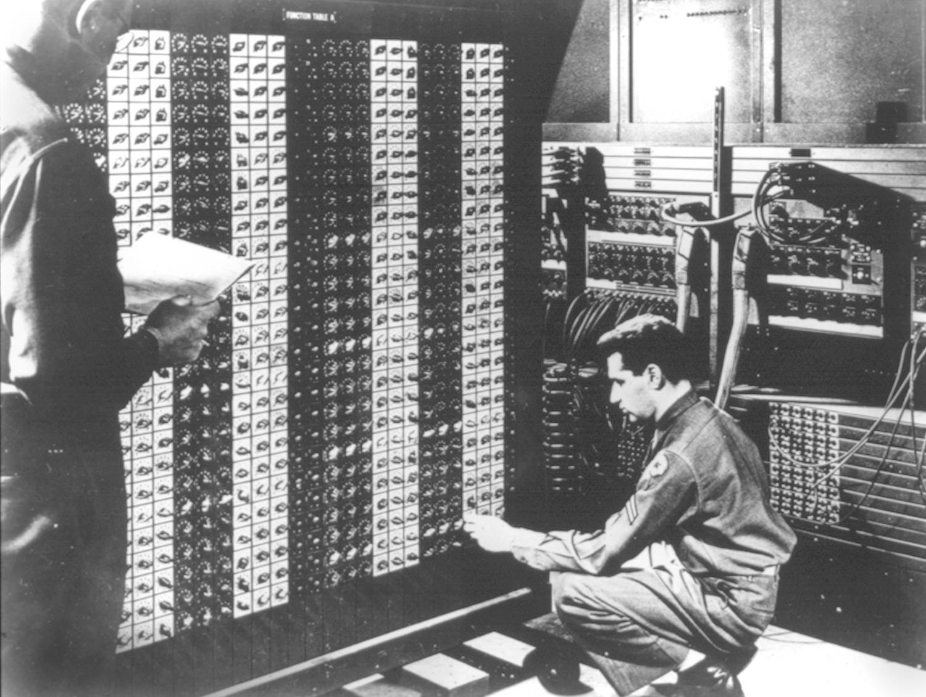
Advanced Placement Computer Science
Unit 3: Object Oriented Programming
Lesson: Interfaces
Last Updated: 11/12/2015

USB is really cool, isn’t it?
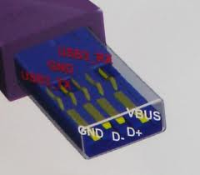 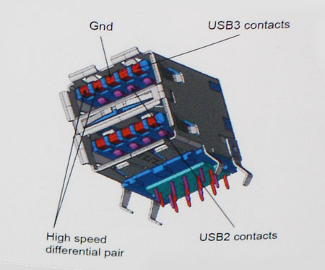
It allows us to plug a thumb drive into any computer that supports USB, and voila, after installing the device driver, you’ve got a removable drive!!!!

Java has a similar concept, interfaces are a collection of methods that must be implemented by a class, a promise from programmer to programmer!
Let’s look at a useful interface.
public interface MouseListener extends EventListener {
/**
* Invoked when the mouse button has been clicked (pressed
* and released) on a component.
*/
public void mouseClicked(MouseEvent e);
/**
* Invoked when a mouse button has been pressed on a component.
*/
public void mousePressed(MouseEvent e);
/**
* Invoked when a mouse button has been released on a component.
*/
public void mouseReleased(MouseEvent e);
/**
* Invoked when the mouse enters a component.
*/
public void mouseEntered(MouseEvent e);
/**
* Invoked when the mouse exits a component.*/
public void mouseExited(MouseEvent e);
}
All methods in an interface must be implemented by the class that implements interface

Differences between interfaces and classes
- There is NO logic or commands in an interface, only method signatures
- Everything is public in an interface, nothing private
- NO variables in an interface

Interfaces guarantee that certain methods are implemented. This helps write more general purpose code.
Some popular interfaces;
Interface | Methods that must be implemented
ActionListener | public void actionPerformed(ActionEvent blah)
Comparable | public int compareTo(Object o)
KeyListener | public void keyPressed (KeyEvent e)  public void keyTyped (KeyEvent e)  public void keyReleased (KeyEvent e)
MouseListener | public void mousePressed(MouseEvent event)  public void mouseClicked(MouseEvent event)  public void mouseReleased(MouseEvent event)  public void mouseEntered(MouseEvent event)  public void mouseExited(MouseEvent event)

Now if we create a class that implements BOTH MouseListener and KeyListener, what do we know?

public class MyFrame implements KeyListener, MouseListener {

//Must implement 3 methods from KL and 5 from MouseListener

}
How about the Comparable interface?
You must define how to compare two objects of your class and rank them
Works like the mathematical operator subtraction
For example, String implements Comparable, so
String s1 = “CAT”, s2 = “DAD”;
int result = s1.compareTo(s2); //what is the value of result??? Since C= 67 in ASCII, and D is 68, this method returns 67-68 which is -1
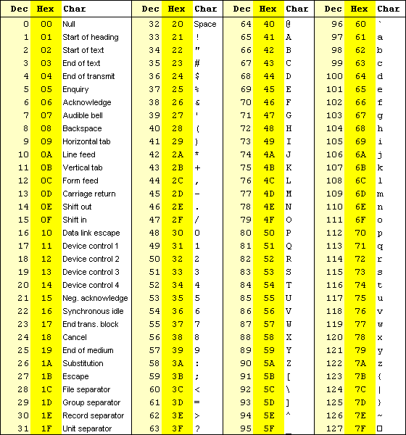
How about “Carly”.compareTo(“Allen”); 67-65 which is 2
How about “Eric”.compareTo(“Erin”); E’s are same so we go to r versus r same so i versus i same so c versus n 99-114 which is -15
How about “Sanjee”.compareT0(“Sanjee”); 0
How about “tea”.compareTo(“teapot”); 0-112 = -112

Summary: 0-112 = -112
What does this allow us to do with Strings?
This allows us to compare strings alphabetically in English and sort them(NOTE: all UPPERCASE comes before all lowercase and space is ascii 32 so it is below them all)

Furthermore, there is a method Collections.sort which will sort any ArrayList of Comparables
ArrayList<String> namesAL = new ArrayList<String>();

namesAL.add("Cara");
namesAL.add("Carly");
namesAL.add("Bob");
namesAL.add("Austin");
namesAL.add("Zoe");
namesAL.add("Jessica");

Collections.sort(namesAL);
for (int i = 0; i < namesAL.size(); i++) {
System.out.println(namesAL.get(i));
}
//OUTPUT
Austin
Bob
Cara
Carly
Jessica
Zoe

How about a TennisPlayer class that implements Comparable?
import java.util.Date;

public class TennisPlayer implements Comparable {

private String lastName, firstName, countryOrigin;
private Date dob;
private int rank, annualEarnings, tourPoints;

public int getRank() { return rank; }

public int compareTo(Object other) {
TennisPlayer oth = (TennisPlayer) other; //must TYPECAST when using compareTo
return rank – oth.getRank();
}
}

How do we use this to test 2 players?
public class Tester {
public static void main(String args[]) {

TennisPlayer rafa = new TennisPlayer(“Nadal”, “Rafael”, “Espana”, new
Date(1986,6,3), 5, 583074, 6675);
TennisPlayer roger = new TennisPlayer(“Federer”, “Roger”, “Switzerland”, new
Date(1981,8,18), 3, 550,017, 5205);
//Write the logic to compare the two players
if(rafa.compareTo(roger)==0){
System.out.println(“Equal”);
}
else if(rafa.compareTo(roger)<0){
System.out.println(“Rafa ranked lower number”);
}
else {
System.out.println(“Rafa ranked higher number”);
}

}
}

Interfaces can also be passed as parameters to a method.
/**
* The <code>AudioClip</code> interface is a simple abstraction for playing a sound clip. Multiple
* <code>AudioClip</code> items can be playing at the same time, and the resulting sound is mixed together to
* produce a composite.
* @author Arthur van Hoff
* @since JDK1.0
*/
public interface AudioClip {
/**
* Starts playing this audio clip. Each time this method is called,
* the clip is restarted from the beginning. */
void play();
/**
* Starts playing this audio clip in a loop. */
void loop();
/**
* Stops playing this audio clip.*/
void stop();
}
Write a method called playIntro that takes in an AudioClip (ac)reference and plays it as the intro to a program
public void playIntro(AudioClip snd) {
snd.play();
}

