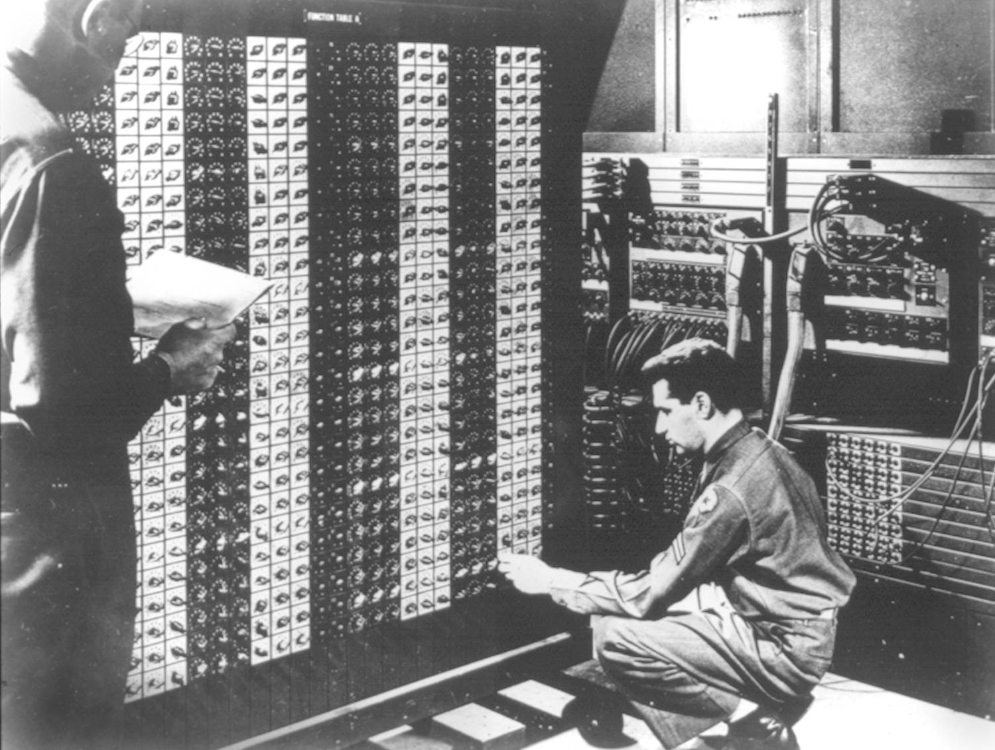
Advanced Placement Computer Science
Shenendehowa HS mr Hanley
Unit 4: Object Oriented Programming
Lesson: Classes
Last Updated: 10/24/2017

Lesson: Parameter Passing Mechanisms
Last Updated: 100/11001/1100

Modern programs are often organized into separate ____________________, each with its own responsibilities.

This began in the 1980’s with the desire to recreate more _________________________________

Classes act as software blueprints, allowing programmers to use some classes to create multiple objects, which contain their own ______________________ and _____________________

While there is only one class, one can create multiple ___________________.
Class | Object
One definition, contains logic that all objects share. Sometimes called behaviors. | Can have multiple instances, each has its own unique data. Share all behaviors via the class
Some classes are built on top of existing classes, this is called __________________ | Executing programs use objects primarily, not classes. Objects send each other messages.
State of an object =
_________________________________________

How does a typical class manage information? There are 4 things inside classes
public class SomeClass {

//Variable Section, typically private so only this class can modify
//Constructors, special methods that ____________________________ objects of this type

//NOTE:

public SomeClass() {
}
public SomeClass(String nm) {

}
//Accessors – must be public

//Mutators – must be public

}
public class UserOfSomeClass {
public static void main(String[ ] args) {
SomeClass s1 = new SomeClass(); //instanciate an object called s1
s1.setName(“Arthur”);
s1.setAge(16);
System.out.println(s1.getAge());
//Use the overloaded constructor to create an object for s2 named “Sara”
//Set her age to 17
//Print out her information
}
Access specifiers
private
public
protected
What is a constructor?

What is a member variable?
What are overloaded methods?
For example, the following structure may apply to a java program;
FILE: Client.java
Contains: main method, which will use 3 Contacts called c1, c2 and c3
main() starts the program and has a main loop
FILE: Contact.java
Contains: no main method, has variables which pertain to a cell phone contact

- public class Contact { //Represents a cell phone contact (Name and Phone Number)

- public class Client {
- public static void main(String[] args) {

- }
54) }

