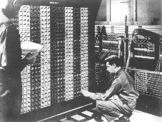
Advanced Placement Computer Science
Shenendehowa HS mr Hanley
Unit 6: Arrays/ArrayList
Lesson: For Each Loop
Last Updated: 2/1/2022

It didn’t take long for programmers to find the need to loop through arrays and ArrayLists and other data structures one element at a time.
To avoid having to use an index, the ________________ was created.

To use it, you must have an Collection or Array
public static void main(String[] args) {
String[] words = {"nihilistic", "apoplectic", "versatile", "juggernaut", "loquacious"};

for(String s: words){
System.out.println(s);
}

//You try.
//Make an ArrayList of the vowels
//Use a for each loop to print to the screen

