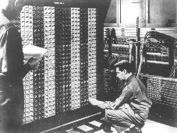
Advanced Placement Computer Science
Shenendehowa HS mr Hanley
Unit 6: Arrays/ArrayLists
Lesson: For Each Loop
Last Updated: 3/24/2014

Lesson: Parameter Passing Mechanisms
Last Updated: 100/11001/1100

It didn’t take long for programmers to find the need to loop through arrays and ArrayLists and other data structures one element at a time.
To avoid having to use an index, the enhanced for loop(for each loop) was created.

To use it, you must have an Collection or Array
public static void main(String[] args) {
String[] words = {"nihilistic", "apoplectic", "versatile", "juggernaut", "loquacious"};

for(String s: words){ //each iteration of for loop, s takes on the next value of array
System.out.println(s);
}
DON’T USE IF REMOVING ELEMENTS FROM ARRAYLIST
//You try.
//Make an ArrayList of the vowels
//Use a for each loop to print to the screen
ArrayList vowels = new ArrayList();
vowels.add(“a”);
vowels.add(“e”);
vowels.add(“i”);
vowels.add(“o”);
vowels.add(“u”);

for(String s:vowels){
System.out.println(s);
}

