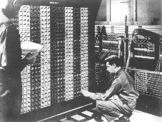
Advanced Placement Computer Science
Shenendehowa HS mr Hanley
Unit 7: I/O Streams
Lesson: Reading and Writing Files
Last Updated: 5/17/2021

Lesson: Parameter Passing Mechanisms
Last Updated: 100/11001/1100

Streams are C++ and Java’s way of standardizing and

A Stream is a sequence of

A byte is a grouping of

Examples of Streams,

Whenever a java application runs, The System static class is created and so is and

When a text file is written to a local disk, an output stream is created

When a text file is read from a local disk, an input stream is created

The next commands shown below is how Josh Komoroske opened a stream to an internet web server.
URL server = null; //A URL represents a uniform resource location
try {
server = new URL(url); //connect to the target URL
} catch (MalformedURLException m) {
throw new Exception(m);
}
BufferedReader in = null; //a buffered reader can process a stream of information
try {
in = new BufferedReader(new InputStreamReader(server.openStream())); //open a new stream buffer
} catch (IOException i) {
throw new Exception(i);
}

There are two different approaches to storing information in files;

There are two different approaches to accessing the stored information in files;

Meet the players;
Class | Useful for | Example
File | Represents an individual file or directory on a disk system.  Used to open and close streams to that file | //Use the File class to see if this is a directory  File searchRoot = new File(fileDir);  if (searchRoot.isDirectory())
FileWriter | Writing ASCII text to a text file. Often used in conjunction with PrintWriter (see below) | //Try to open the stream for writing...  try {  FileWriter fw;  fw = new FileWriter("output.txt"); //if file is already there, this will blow it away  PrintWriter pw = new PrintWriter(fw);  pw.println(“Two Roads Diverged in a Wood and I”);  pw.println(“I took the one less traveled by”);  pw.println(“And that has made all the difference”);  }catch(Exception e)  {  System.out.println("Can't open file");  }  fw.close();

PrintWriter | Allows for easy access to putting information to the file, using print and println.  Works just like System.out except data is written to a text file instead of the console. | See above example
FileReader | Reading ASCII text from an opened text file | BufferedReader input = new BufferedReader(new FileReader("data.txt"));
BufferedReader | Useful for reading text files one line at a time. (Buffering also helps over a network or internet connection) | See above
StringTokenizer | Breaks up a String into tokens or smaller Strings | StringTokenizer st = new StringTokenizer(line, "|");
Scanner | Scanner can be used to read the text files as well | try {  //Attempt to open the file  File f = new File(fileName);  //Assuming its open, let's grab the info  Scanner input = new Scanner(f);  while (input.hasNext()) {  //Read the currency  String descript = input.nextLine();  String temp = input.nextLine();  double convertRate = Double.parseDouble(temp);  //Now create a new Currency object  Currency tempCurrency = new Currency(descript, convertRate);  //Add into the array  if (numRates < 100) {  rates[numRates] = tempCurrency;  numRates++;  }  }  input.close();  }  catch (Exception e) {  sc.println(" --------------------------");  sc.println("| FILE problem |");  sc.println(" --------------------------");  sc.println(e); //print the exception  }

Here is what the rates.txt file looks like;
Euro
0.74895
Great Britain Pounds
0.51481
Japanese Yen
117.650
Chinese Yen
7.74529
Mexican Peso
11.2075
Canadian Dollar
1.17725
Pakistani Rupee
60.7170

NOTE: Be careful with the last line and blank lines at the end of the file!!!

NOTE: Files must be in the project directory (NOT the source or class directory)

Steps for Writing a File:
1. Open the file for writing (can either APPEND or OVERWRITE)
APPEND =
OVERWRITE =

Let’s write out the first and last names from an array to a text file called roster.txt

public static void main(String[] args){
String[ ]names = {“Karl Marx”, “Abe Lincoln”, “Theodore Roosevelt”, “Aung San Suu Kyi”, “Alfred Nobel”};

try {

} catch (IOException ex) {

}
}
Steps for Reading a File:

import java.io.File;
import java.io.FileNotFoundException;
import java.util.ArrayList;
import java.util.Scanner;
import java.util.logging.Level;
import java.util.logging.Logger;

public class ReadNamesUsingScannerSolFromNotes {

public static void main(String[] args) {

ArrayList<String>names = new ArrayList<String>();
try {
Scanner inFile = new Scanner(new File("names.txt")); //looks in proj folder

while(inFile.hasNext()){
names.add(inFile.nextLine());

}
inFile.close();
} catch (FileNotFoundException ex) {
Logger.getLogger(ReadNamesUsingScannerSolFromNotes.class.getName()).log(Level.SEVERE, null, ex);
}
for (int i = 0; i < names.size(); i++) {
System.out.println(names.get(i));

}

}
}

Mr Hanley’s preferred way of storing information:
I prefer to store information with each record on a single line

As an example, consider this text file

McCarthy|Walter|255 Grapevine Rd|Wenham|MA|01984|12000.00
NaSmith|Courtney|7 Main St.|Clifton Park|NY|12065|18000.00
Anderson|Trinity|957 First St.|Hermosa Beach|CA|01954|19000.00

/*=============================================
= FILE: ReadFileUnsureSizStringTokSol.java
= DATE: 2/2/2004
= AUTHOR: han1337
= PURPOSE: Demonstrate reading data of unknown size
=============================================*/
import java.io.*;
import java.util.*;
import java.util.StringTokenizer;

/*File could look like this
McCarthy|Walter|255 Grapevine Rd|Wenham|MA|01984|12000.00
NaSmith|Courtney|7 Main St.|Clifton Park|NY|12065|18000.00
Anderson|Trinity|957 First St.|Hermosa Beach|CA|01954|19000.00
*/
public class ReadFileUnsureSizeStringTokSol
{
String fname, lname, streetAddr, town, state, zip;
double salary;

public ReadFileUnsureSizeStringTokSol()
{
read();
}

public void read()
{
try
{
BufferedReader input = new BufferedReader(new FileReader("data.txt"));

String line;
//Attempt to read from the file
line = input.readLine(); //Prime the pump

while (line != null) //goes to the end of file
{
StringTokenizer st = new StringTokenizer(line, "|"); //| is the delimiter
//Now break up the line
lname = st.nextToken();
fname = st.nextToken();
streetAddr = st.nextToken();
town = st.nextToken();
state = st.nextToken();
zip = st.nextToken();
salary = Double.parseDouble(st.nextToken());

System.out.println("Here's our info " + fname + " " + lname + " " +
streetAddr + " " + town + " " + state + " " + zip +
" "
+ salary);
line = input.readLine();
}
input.close();
}
catch (Exception e)
{
System.out.println(e.toString());
}
}
public static void main(String[] args)
{
ReadFileUnsureSizeStringTokSol rfus = new ReadFileUnsureSizeStringTokSol();
}
}
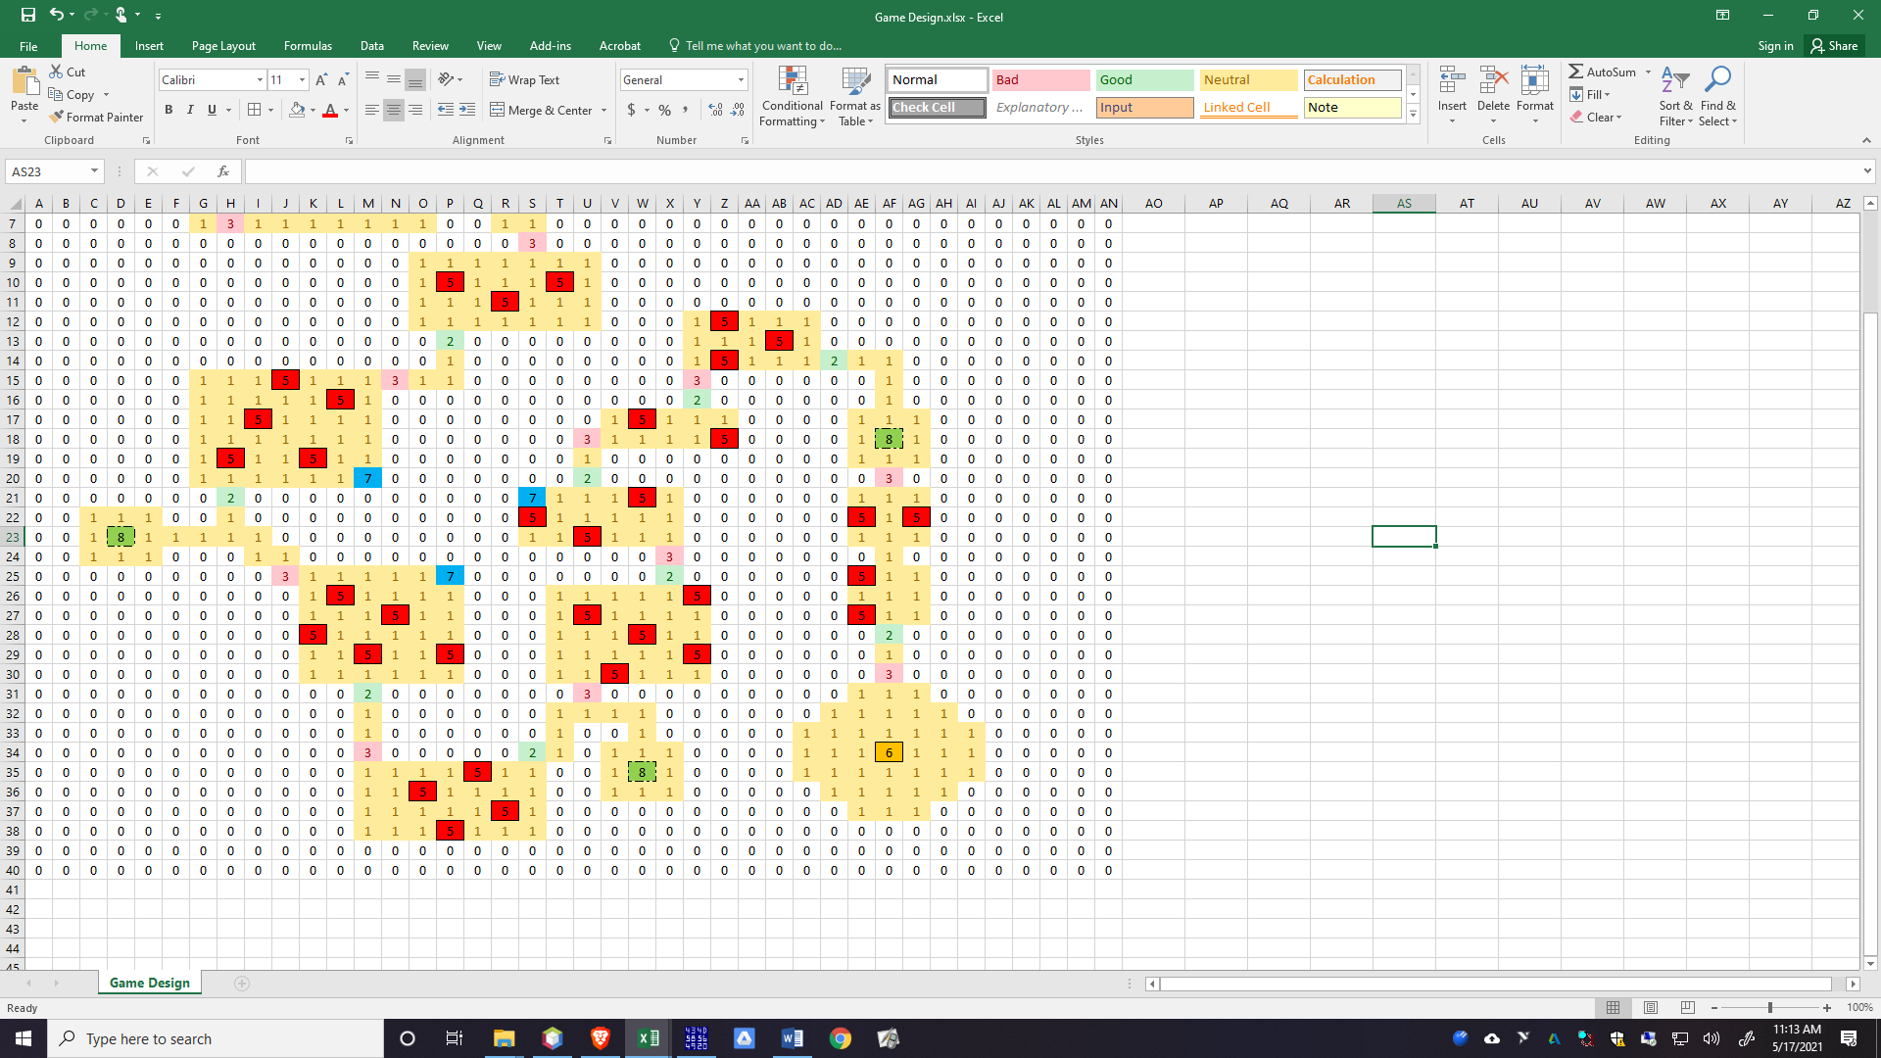
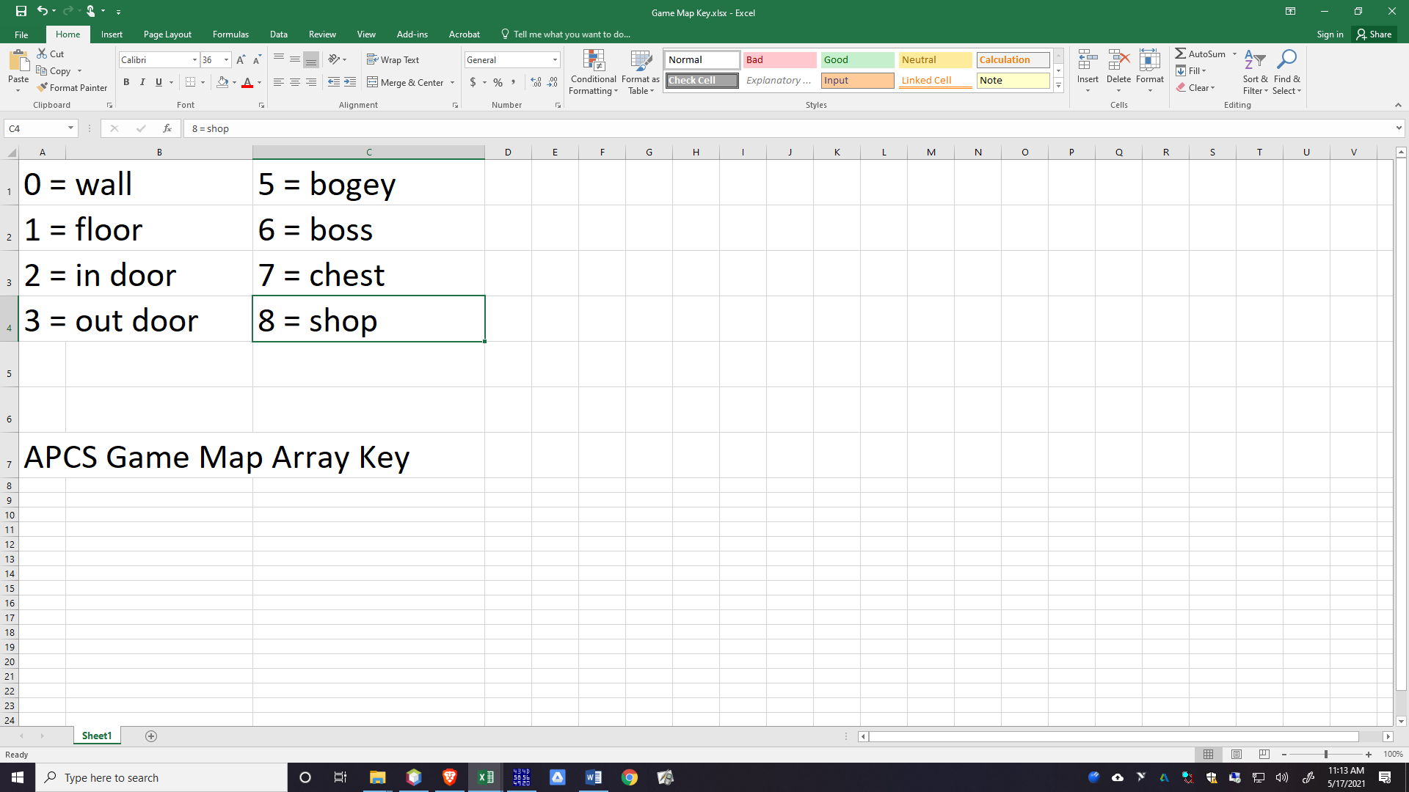

EXAMPLE Pat Moore CSV File for Maze Game.
Pat Moore(2019 Grad) developed a spreadsheet and then save as…csv or comma separated
Here is the file:
0,0,0,0,0,0,0,0,0,0,0,0,0,0,0,0,0,0,0,0,0,0,0,0,0,0,0,0,0,0,0,0,0,0,0,0,0,0,0,0
0,1,1,1,1,7,0,0,0,0,0,0,0,0,0,0,0,0,0,0,0,0,0,0,0,0,0,0,0,0,0,0,0,0,0,0,0,0,0,0
0,1,1,1,1,1,0,0,0,0,0,0,0,0,0,0,0,0,0,0,0,0,0,0,0,0,0,0,0,0,0,0,0,0,0,0,0,0,0,0
0,8,1,1,1,1,0,0,1,1,1,1,1,1,7,0,0,0,0,0,0,0,0,0,0,0,0,0,0,0,0,0,0,0,0,0,0,0,0,0
0,0,0,0,0,1,0,0,1,5,1,1,1,5,1,0,0,0,0,0,0,0,0,0,0,0,0,0,0,0,0,0,0,0,0,0,0,0,0,0
0,0,0,0,0,1,1,0,1,1,1,5,1,1,1,2,1,1,0,0,0,0,0,0,0,0,0,0,0,0,0,0,0,0,0,0,0,0,0,0
0,0,0,0,0,0,1,3,1,1,1,1,1,1,1,0,0,1,1,0,0,0,0,0,0,0,0,0,0,0,0,0,0,0,0,0,0,0,0,0
0,0,0,0,0,0,0,0,0,0,0,0,0,0,0,0,0,0,3,0,0,0,0,0,0,0,0,0,0,0,0,0,0,0,0,0,0,0,0,0
0,0,0,0,0,0,0,0,0,0,0,0,0,0,1,1,1,1,1,1,1,0,0,0,0,0,0,0,0,0,0,0,0,0,0,0,0,0,0,0
0,0,0,0,0,0,0,0,0,0,0,0,0,0,1,5,1,1,1,5,1,0,0,0,0,0,0,0,0,0,0,0,0,0,0,0,0,0,0,0
0,0,0,0,0,0,0,0,0,0,0,0,0,0,1,1,1,5,1,1,1,0,0,0,0,0,0,0,0,0,0,0,0,0,0,0,0,0,0,0
0,0,0,0,0,0,0,0,0,0,0,0,0,0,1,1,1,1,1,1,1,0,0,0,1,5,1,1,1,0,0,0,0,0,0,0,0,0,0,0
0,0,0,0,0,0,0,0,0,0,0,0,0,0,0,2,0,0,0,0,0,0,0,0,1,1,1,5,1,0,0,0,0,0,0,0,0,0,0,0
0,0,0,0,0,0,0,0,0,0,0,0,0,0,0,1,0,0,0,0,0,0,0,0,1,5,1,1,1,2,1,1,0,0,0,0,0,0,0,0
0,0,0,0,0,0,1,1,1,5,1,1,1,3,1,1,0,0,0,0,0,0,0,0,3,0,0,0,0,0,0,1,0,0,0,0,0,0,0,0
0,0,0,0,0,0,1,1,1,1,1,5,1,0,0,0,0,0,0,0,0,0,0,0,2,0,0,0,0,0,0,1,0,0,0,0,0,0,0,0
0,0,0,0,0,0,1,1,5,1,1,1,1,0,0,0,0,0,0,0,0,1,5,1,1,1,0,0,0,0,1,1,1,0,0,0,0,0,0,0
0,0,0,0,0,0,1,1,1,1,1,1,1,0,0,0,0,0,0,0,3,1,1,1,1,5,0,0,0,0,1,8,1,0,0,0,0,0,0,0
0,0,0,0,0,0,1,5,1,1,5,1,1,0,0,0,0,0,0,0,1,0,0,0,0,0,0,0,0,0,1,1,1,0,0,0,0,0,0,0
0,0,0,0,0,0,1,1,1,1,1,1,7,0,0,0,0,0,0,0,2,0,0,0,0,0,0,0,0,0,0,3,0,0,0,0,0,0,0,0
0,0,0,0,0,0,0,2,0,0,0,0,0,0,0,0,0,0,7,1,1,1,5,1,0,0,0,0,0,0,1,1,1,0,0,0,0,0,0,0
0,0,1,1,1,0,0,1,0,0,0,0,0,0,0,0,0,0,5,1,1,1,1,1,0,0,0,0,0,0,5,1,5,0,0,0,0,0,0,0
0,0,1,8,1,1,1,1,1,0,0,0,0,0,0,0,0,0,1,1,5,1,1,1,0,0,0,0,0,0,1,1,1,0,0,0,0,0,0,0
0,0,1,1,1,0,0,0,1,1,0,0,0,0,0,0,0,0,0,0,0,0,0,3,0,0,0,0,0,0,0,1,0,0,0,0,0,0,0,0
0,0,0,0,0,0,0,0,0,3,1,1,1,1,1,7,0,0,0,0,0,0,0,2,0,0,0,0,0,0,5,1,1,0,0,0,0,0,0,0
0,0,0,0,0,0,0,0,0,0,1,5,1,1,1,1,0,0,0,1,1,1,1,1,5,0,0,0,0,0,1,1,1,0,0,0,0,0,0,0
0,0,0,0,0,0,0,0,0,0,1,1,1,5,1,1,0,0,0,1,5,1,1,1,1,0,0,0,0,0,5,1,1,0,0,0,0,0,0,0
0,0,0,0,0,0,0,0,0,0,5,1,1,1,1,1,0,0,0,1,1,1,5,1,1,0,0,0,0,0,0,2,0,0,0,0,0,0,0,0
0,0,0,0,0,0,0,0,0,0,1,1,5,1,1,5,0,0,0,1,1,1,1,1,5,0,0,0,0,0,0,1,0,0,0,0,0,0,0,0
0,0,0,0,0,0,0,0,0,0,1,1,1,1,1,1,0,0,0,1,1,5,1,1,1,0,0,0,0,0,0,3,0,0,0,0,0,0,0,0
0,0,0,0,0,0,0,0,0,0,0,0,2,0,0,0,0,0,0,0,3,0,0,0,0,0,0,0,0,0,1,1,1,0,0,0,0,0,0,0
0,0,0,0,0,0,0,0,0,0,0,0,1,0,0,0,0,0,0,1,1,1,1,0,0,0,0,0,0,1,1,1,1,1,0,0,0,0,0,0
0,0,0,0,0,0,0,0,0,0,0,0,1,0,0,0,0,0,0,1,0,0,1,0,0,0,0,0,1,1,1,1,1,1,1,0,0,0,0,0
0,0,0,0,0,0,0,0,0,0,0,0,3,0,0,0,0,0,2,1,0,1,1,1,0,0,0,0,1,1,1,6,1,1,1,0,0,0,0,0
0,0,0,0,0,0,0,0,0,0,0,0,1,1,1,1,5,1,1,0,0,1,8,1,0,0,0,0,1,1,1,1,1,1,1,0,0,0,0,0
0,0,0,0,0,0,0,0,0,0,0,0,1,1,5,1,1,1,1,0,0,1,1,1,0,0,0,0,0,1,1,1,1,1,0,0,0,0,0,0
0,0,0,0,0,0,0,0,0,0,0,0,1,1,1,1,1,5,1,0,0,0,0,0,0,0,0,0,0,0,1,1,1,0,0,0,0,0,0,0
0,0,0,0,0,0,0,0,0,0,0,0,1,1,1,5,1,1,1,0,0,0,0,0,0,0,0,0,0,0,0,0,0,0,0,0,0,0,0,0
0,0,0,0,0,0,0,0,0,0,0,0,0,0,0,0,0,0,0,0,0,0,0,0,0,0,0,0,0,0,0,0,0,0,0,0,0,0,0,0
0,0,0,0,0,0,0,0,0,0,0,0,0,0,0,0,0,0,0,0,0,0,0,0,0,0,0,0,0,0,0,0,0,0,0,0,0,0,0,0

My Logic to read in Pat’s File:
public class ReadFile {
public static void main(String[] args) {
Scanner input = new Scanner(System.in);
int[][] gameWorld = new int[40][40];
try {
BufferedReader br = new BufferedReader
(new FileReader("Game Design.csv"));
String line = br.readLine();
int r=0;

while(line != null){

StringTokenizer st = new StringTokenizer(line,",");
int c=0;
while(st.hasMoreElements()){
gameWorld[r][c]=Integer.parseInt
(st.nextToken());
c++;
}
r++;
line = br.readLine();
//Break up this line into the array
}
} catch (FileNotFoundException ex) {
Logger.getLogger(ReadFile.class.getName())
.log(Level.SEVERE, null, ex);
}
catch (IOException ex) {
Logger.getLogger(ReadFile.class.getName())
.log(Level.SEVERE, null, ex);
}
//Display Array
for(int r=0;r<40;r++){
for(int c=0;c<40;c++){
System.out.print(gameWorld[r][c]+" ");
}
System.out.println("");
}
}
}

