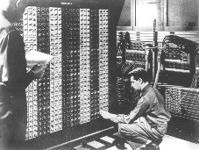
Advanced Placement Computer Science
Shenendehowa HS mr Hanley
Unit 7: I/O Streams
Lesson: Reading and Writing Files
Last Updated: 5/17/2021

Lesson: Parameter Passing Mechanisms
Last Updated: 100/11001/1100

Streams are C++ and Java’s way of standardizing input and output

A Stream is a sequence of bits (binary digit, an on or off switch)

A byte is a grouping of 8 bits (256 combinations or one English letter)

Examples of Streams,

Whenever a java application runs, The System static class is created and so is and System.in(keyboard by default), System.out(Console screen by default)

When a text file is written to a local disk, an output stream is created

When a text file is read from a local disk, an input stream is created

The next commands shown below is how Josh Komoroske opened a stream to an internet web server.
URL server = null; //A URL represents a uniform resource location
try {
server = new URL(url); //connect to the target URL
} catch (MalformedURLException m) {
throw new Exception(m);
}
BufferedReader in = null; //a buffered reader can process a stream of information
try {
in = new BufferedReader(new InputStreamReader(server.openStream())); //open a new stream buffer
} catch (IOException i) {
throw new Exception(i);
}

There are two different approaches to storing information in files;
- Text Files: They store a series of ASCII codes. Examples, files that can be read with NotePad or WordPad
- Binary Files:Raw byte data that must be interpreted…could be an image like .jpg, .gif, .bmp, Sound Files, .wav, .mp3
Level from Call of Duty…compiled programs, satellite photos
There are two different approaches to accessing the stored information in files;
- Sequential File Access: Read a file from start to finish. Easiest to Use.
- Random File Access: Jump as many bytes as possible in the file.
Harder to use, but more powerful.

Meet the players;
Class | Useful for | Example
File | Represents an individual file or directory on a disk system.  Used to open and close streams to that file | //Use the File class to see if this is a directory  File searchRoot = new File(fileDir);  if (searchRoot.isDirectory())
FileWriter | Writing ASCII text to a text file. Often used in conjunction with PrintWriter (see below) | //Try to open the stream for writing...  try {  FileWriter fw;  fw = new FileWriter("output.txt"); //if file is already there, this will blow it away  PrintWriter pw = new PrintWriter(fw);  pw.println(“Two Roads Diverged in a Wood and I”);  pw.println(“I took the one less traveled by”);  pw.println(“And that has made all the difference”);  }catch(Exception e)  {  System.out.println("Can't open file");  }  fw.close();

PrintWriter | Allows for easy access to putting information to the file, using print and println.  Works just like System.out except data is written to a text file instead of the console. | See above example
FileReader | Reading ASCII text from an opened text file | BufferedReader input = new BufferedReader(new FileReader("data.txt"));
BufferedReader | Useful for reading text files one line at a time. (Buffering also helps over a network or internet connection) | See above
StringTokenizer | Breaks up a String into tokens or smaller Strings | StringTokenizer st = new StringTokenizer(line, "|");
Scanner | Scanner can be used to read the text files as well | try {  //Attempt to open the file  File f = new File(fileName);  //Assuming its open, let's grab the info  Scanner input = new Scanner(f);  while (input.hasNext()) {  //Read the currency  String descript = input.nextLine();  String temp = input.nextLine();  double convertRate = Double.parseDouble(temp);  //Now create a new Currency object  Currency tempCurrency = new Currency(descript, convertRate);  //Add into the array  if (numRates < 100) {  rates[numRates] = tempCurrency;  numRates++;  }  }  input.close();  }  catch (Exception e) {  sc.println(" --------------------------");  sc.println("| FILE problem |");  sc.println(" --------------------------");  sc.println(e); //print the exception  }

Here is what the rates.txt file looks like;
Euro
0.74895
Great Britain Pounds
0.51481
Japanese Yen
117.650
Chinese Yen
7.74529
Mexican Peso
11.2075
Canadian Dollar
1.17725
Pakistani Rupee
60.7170

NOTE: Be careful with the last line and blank lines at the end of the file!!!

NOTE: Files must be in the project directory (NOT the source or class directory)

Steps for Writing a File:
1. Open the file for writing (can either APPEND or OVERWRITE)
APPEND = Add to the end, don’t delete everything that is there, log files, diaries, etc.
OVERWRITE = Blow the file away, create it new…

Let’s write out the first and last names from an array to a text file called roster.txt

public static void main(String[] args){
String[ ]names = {“Karl Marx”, “Abe Lincoln”, “Theodore Roosevelt”, “Aung San Suu Kyi”, “Alfred Nobel”};

try {

FileWriter fw = new FileWriter(new File(“roster.txt”));
PrintWriter pw = new PrintWriter(fw);
for(String n:names){
pw.println(n);
}
fw.close();

} catch (IOException ex) {

}
}
Steps for Reading a File:
Create a scanner or Buffered Reader
Open the file
Repeat the readln command(or nextLine)
Close the Stream

import java.io.File;
import java.io.FileNotFoundException;
import java.util.ArrayList;
import java.util.Scanner;
import java.util.logging.Level;
import java.util.logging.Logger;

public class ReadNamesUsingScannerSolFromNotes {

public static void main(String[] args) {

ArrayList<String>names = new ArrayList<String>();
try {
Scanner inFile = new Scanner(new File("names.txt")); //looks in proj folder

while(inFile.hasNext()){
names.add(inFile.nextLine());

}
inFile.close();
} catch (FileNotFoundException ex) {
Logger.getLogger(ReadNamesUsingScannerSolFromNotes.class.getName()).log(Level.SEVERE, null, ex);
}
for (int i = 0; i < names.size(); i++) {
System.out.println(names.get(i));

}

}
}

Mr Hanley’s preferred way of storing information:
I prefer to store information with each record on a single line

As an example, consider this text file

McCarthy|Walter|255 Grapevine Rd|Wenham|MA|01984|12000.00
NaSmith|Courtney|7 Main St.|Clifton Park|NY|12065|18000.00
Anderson|Trinity|957 First St.|Hermosa Beach|CA|01954|19000.00

/*=============================================
= FILE: ReadFileUnsureSizStringTokSol.java
= DATE: 2/2/2004
= AUTHOR: han1337
= PURPOSE: Demonstrate reading data of unknown size
=============================================*/
import java.io.*;
import java.util.*;
import java.util.StringTokenizer;

/*File could look like this
McCarthy|Walter|255 Grapevine Rd|Wenham|MA|01984|12000.00
NaSmith|Courtney|7 Main St.|Clifton Park|NY|12065|18000.00
Anderson|Trinity|957 First St.|Hermosa Beach|CA|01954|19000.00
*/
public class ReadFileUnsureSizeStringTokSol
{
String fname, lname, streetAddr, town, state, zip;
double salary;

public ReadFileUnsureSizeStringTokSol()
{
read();
}

public void read()
{
try
{
BufferedReader input = new BufferedReader(new FileReader("data.txt"));

String line;
//Attempt to read from the file
line = input.readLine(); //Prime the pump

while (line != null) //goes to the end of file
{
StringTokenizer st = new StringTokenizer(line, "|"); //| is the delimiter
//Now break up the line
lname = st.nextToken();
fname = st.nextToken();
streetAddr = st.nextToken();
town = st.nextToken();
state = st.nextToken();
zip = st.nextToken();
salary = Double.parseDouble(st.nextToken());

System.out.println("Here's our info " + fname + " " + lname + " " +
streetAddr + " " + town + " " + state + " " + zip +
" "
+ salary);
line = input.readLine();
}
input.close();
}
catch (Exception e)
{
System.out.println(e.toString());
}
}
public static void main(String[] args)
{
ReadFileUnsureSizeStringTokSol rfus = new ReadFileUnsureSizeStringTokSol();
}
}
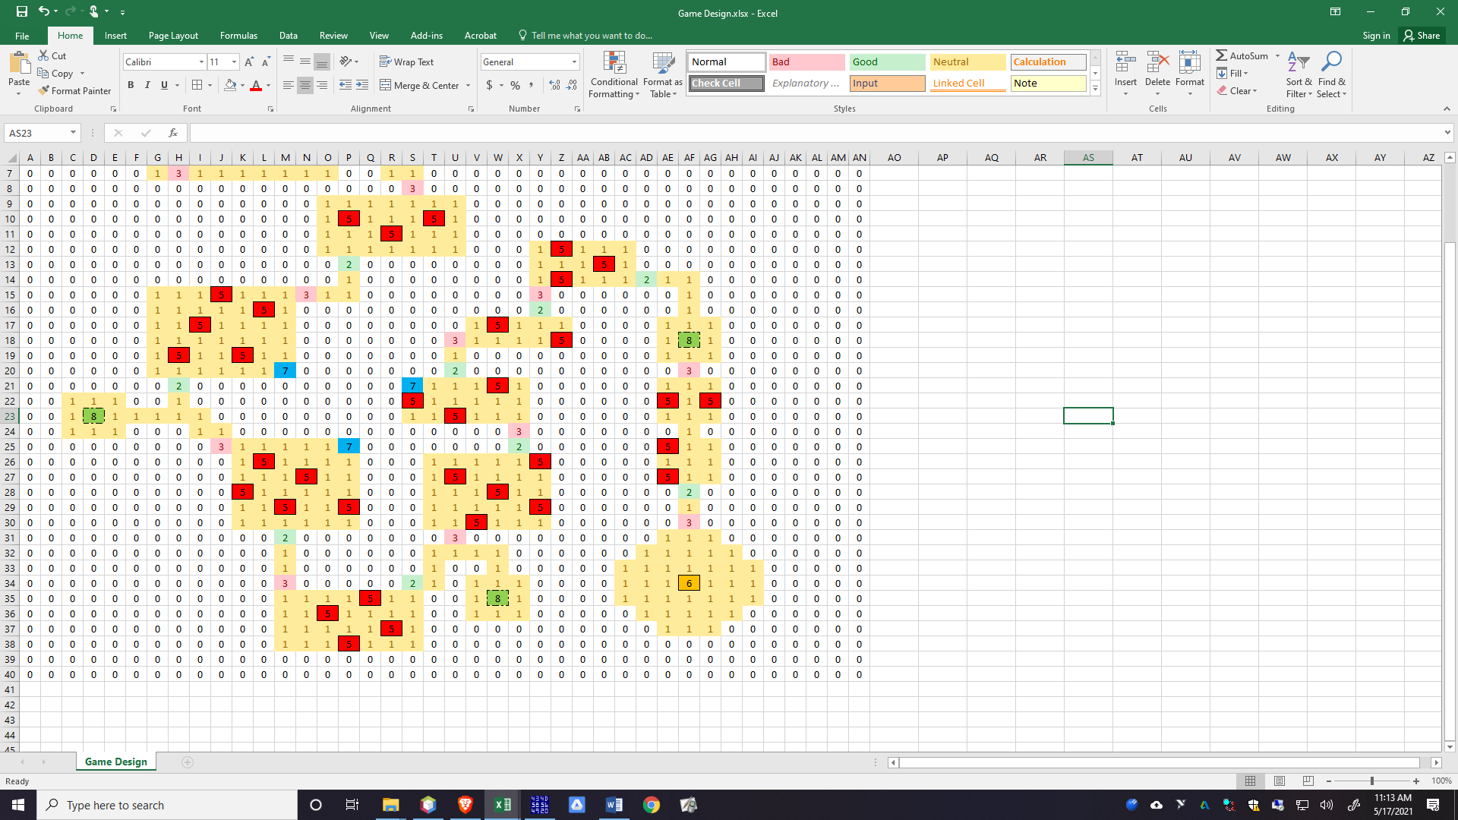
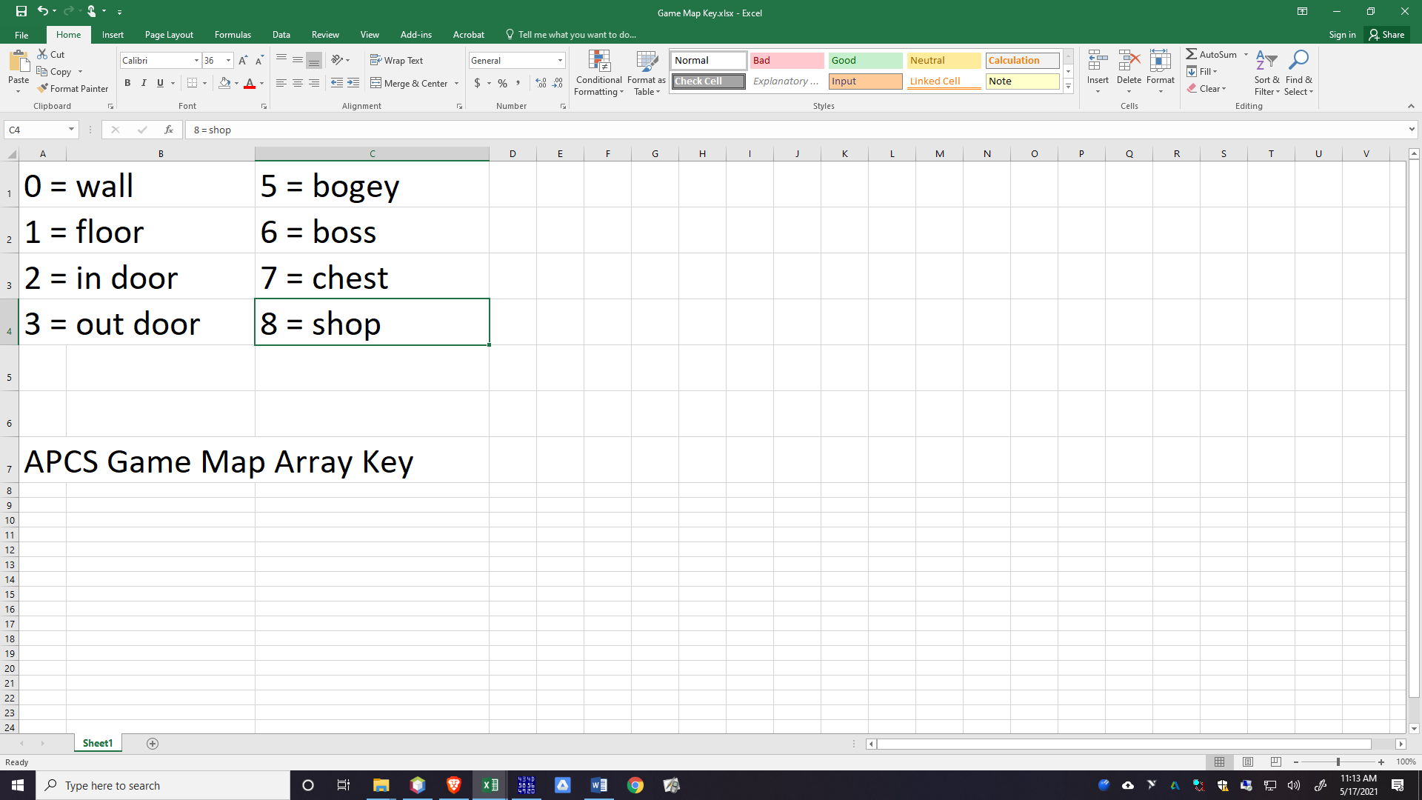

EXAMPLE Pat Moore CSV File for Maze Game.
Pat Moore(2019 Grad) developed a spreadsheet and then save as…csv or comma separated
Here is the file:
0,0,0,0,0,0,0,0,0,0,0,0,0,0,0,0,0,0,0,0,0,0,0,0,0,0,0,0,0,0,0,0,0,0,0,0,0,0,0,0
0,1,1,1,1,7,0,0,0,0,0,0,0,0,0,0,0,0,0,0,0,0,0,0,0,0,0,0,0,0,0,0,0,0,0,0,0,0,0,0
0,1,1,1,1,1,0,0,0,0,0,0,0,0,0,0,0,0,0,0,0,0,0,0,0,0,0,0,0,0,0,0,0,0,0,0,0,0,0,0
0,8,1,1,1,1,0,0,1,1,1,1,1,1,7,0,0,0,0,0,0,0,0,0,0,0,0,0,0,0,0,0,0,0,0,0,0,0,0,0
0,0,0,0,0,1,0,0,1,5,1,1,1,5,1,0,0,0,0,0,0,0,0,0,0,0,0,0,0,0,0,0,0,0,0,0,0,0,0,0
0,0,0,0,0,1,1,0,1,1,1,5,1,1,1,2,1,1,0,0,0,0,0,0,0,0,0,0,0,0,0,0,0,0,0,0,0,0,0,0
0,0,0,0,0,0,1,3,1,1,1,1,1,1,1,0,0,1,1,0,0,0,0,0,0,0,0,0,0,0,0,0,0,0,0,0,0,0,0,0
0,0,0,0,0,0,0,0,0,0,0,0,0,0,0,0,0,0,3,0,0,0,0,0,0,0,0,0,0,0,0,0,0,0,0,0,0,0,0,0
0,0,0,0,0,0,0,0,0,0,0,0,0,0,1,1,1,1,1,1,1,0,0,0,0,0,0,0,0,0,0,0,0,0,0,0,0,0,0,0
0,0,0,0,0,0,0,0,0,0,0,0,0,0,1,5,1,1,1,5,1,0,0,0,0,0,0,0,0,0,0,0,0,0,0,0,0,0,0,0
0,0,0,0,0,0,0,0,0,0,0,0,0,0,1,1,1,5,1,1,1,0,0,0,0,0,0,0,0,0,0,0,0,0,0,0,0,0,0,0
0,0,0,0,0,0,0,0,0,0,0,0,0,0,1,1,1,1,1,1,1,0,0,0,1,5,1,1,1,0,0,0,0,0,0,0,0,0,0,0
0,0,0,0,0,0,0,0,0,0,0,0,0,0,0,2,0,0,0,0,0,0,0,0,1,1,1,5,1,0,0,0,0,0,0,0,0,0,0,0
0,0,0,0,0,0,0,0,0,0,0,0,0,0,0,1,0,0,0,0,0,0,0,0,1,5,1,1,1,2,1,1,0,0,0,0,0,0,0,0
0,0,0,0,0,0,1,1,1,5,1,1,1,3,1,1,0,0,0,0,0,0,0,0,3,0,0,0,0,0,0,1,0,0,0,0,0,0,0,0
0,0,0,0,0,0,1,1,1,1,1,5,1,0,0,0,0,0,0,0,0,0,0,0,2,0,0,0,0,0,0,1,0,0,0,0,0,0,0,0
0,0,0,0,0,0,1,1,5,1,1,1,1,0,0,0,0,0,0,0,0,1,5,1,1,1,0,0,0,0,1,1,1,0,0,0,0,0,0,0
0,0,0,0,0,0,1,1,1,1,1,1,1,0,0,0,0,0,0,0,3,1,1,1,1,5,0,0,0,0,1,8,1,0,0,0,0,0,0,0
0,0,0,0,0,0,1,5,1,1,5,1,1,0,0,0,0,0,0,0,1,0,0,0,0,0,0,0,0,0,1,1,1,0,0,0,0,0,0,0
0,0,0,0,0,0,1,1,1,1,1,1,7,0,0,0,0,0,0,0,2,0,0,0,0,0,0,0,0,0,0,3,0,0,0,0,0,0,0,0
0,0,0,0,0,0,0,2,0,0,0,0,0,0,0,0,0,0,7,1,1,1,5,1,0,0,0,0,0,0,1,1,1,0,0,0,0,0,0,0
0,0,1,1,1,0,0,1,0,0,0,0,0,0,0,0,0,0,5,1,1,1,1,1,0,0,0,0,0,0,5,1,5,0,0,0,0,0,0,0
0,0,1,8,1,1,1,1,1,0,0,0,0,0,0,0,0,0,1,1,5,1,1,1,0,0,0,0,0,0,1,1,1,0,0,0,0,0,0,0
0,0,1,1,1,0,0,0,1,1,0,0,0,0,0,0,0,0,0,0,0,0,0,3,0,0,0,0,0,0,0,1,0,0,0,0,0,0,0,0
0,0,0,0,0,0,0,0,0,3,1,1,1,1,1,7,0,0,0,0,0,0,0,2,0,0,0,0,0,0,5,1,1,0,0,0,0,0,0,0
0,0,0,0,0,0,0,0,0,0,1,5,1,1,1,1,0,0,0,1,1,1,1,1,5,0,0,0,0,0,1,1,1,0,0,0,0,0,0,0
0,0,0,0,0,0,0,0,0,0,1,1,1,5,1,1,0,0,0,1,5,1,1,1,1,0,0,0,0,0,5,1,1,0,0,0,0,0,0,0
0,0,0,0,0,0,0,0,0,0,5,1,1,1,1,1,0,0,0,1,1,1,5,1,1,0,0,0,0,0,0,2,0,0,0,0,0,0,0,0
0,0,0,0,0,0,0,0,0,0,1,1,5,1,1,5,0,0,0,1,1,1,1,1,5,0,0,0,0,0,0,1,0,0,0,0,0,0,0,0
0,0,0,0,0,0,0,0,0,0,1,1,1,1,1,1,0,0,0,1,1,5,1,1,1,0,0,0,0,0,0,3,0,0,0,0,0,0,0,0
0,0,0,0,0,0,0,0,0,0,0,0,2,0,0,0,0,0,0,0,3,0,0,0,0,0,0,0,0,0,1,1,1,0,0,0,0,0,0,0
0,0,0,0,0,0,0,0,0,0,0,0,1,0,0,0,0,0,0,1,1,1,1,0,0,0,0,0,0,1,1,1,1,1,0,0,0,0,0,0
0,0,0,0,0,0,0,0,0,0,0,0,1,0,0,0,0,0,0,1,0,0,1,0,0,0,0,0,1,1,1,1,1,1,1,0,0,0,0,0
0,0,0,0,0,0,0,0,0,0,0,0,3,0,0,0,0,0,2,1,0,1,1,1,0,0,0,0,1,1,1,6,1,1,1,0,0,0,0,0
0,0,0,0,0,0,0,0,0,0,0,0,1,1,1,1,5,1,1,0,0,1,8,1,0,0,0,0,1,1,1,1,1,1,1,0,0,0,0,0
0,0,0,0,0,0,0,0,0,0,0,0,1,1,5,1,1,1,1,0,0,1,1,1,0,0,0,0,0,1,1,1,1,1,0,0,0,0,0,0
0,0,0,0,0,0,0,0,0,0,0,0,1,1,1,1,1,5,1,0,0,0,0,0,0,0,0,0,0,0,1,1,1,0,0,0,0,0,0,0
0,0,0,0,0,0,0,0,0,0,0,0,1,1,1,5,1,1,1,0,0,0,0,0,0,0,0,0,0,0,0,0,0,0,0,0,0,0,0,0
0,0,0,0,0,0,0,0,0,0,0,0,0,0,0,0,0,0,0,0,0,0,0,0,0,0,0,0,0,0,0,0,0,0,0,0,0,0,0,0
0,0,0,0,0,0,0,0,0,0,0,0,0,0,0,0,0,0,0,0,0,0,0,0,0,0,0,0,0,0,0,0,0,0,0,0,0,0,0,0

My Logic to read in Pat’s File:
public class ReadFile {
public static void main(String[] args) {
Scanner input = new Scanner(System.in);
int[][] gameWorld = new int[40][40];
try {
BufferedReader br = new BufferedReader
(new FileReader("Game Design.csv"));
String line = br.readLine();
int r=0;

while(line != null){

StringTokenizer st = new StringTokenizer(line,",");
int c=0;
while(st.hasMoreElements()){
gameWorld[r][c]=Integer.parseInt
(st.nextToken());
c++;
}
r++;
line = br.readLine();
//Break up this line into the array
}
} catch (FileNotFoundException ex) {
Logger.getLogger(ReadFile.class.getName())
.log(Level.SEVERE, null, ex);
}
catch (IOException ex) {
Logger.getLogger(ReadFile.class.getName())
.log(Level.SEVERE, null, ex);
}
//Display Array
for(int r=0;r<40;r++){
for(int c=0;c<40;c++){
System.out.print(gameWorld[r][c]+" ");
}
System.out.println("");
}
}
}

