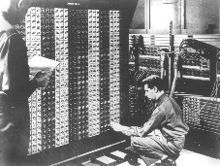
Advanced Placement Computer Science
Shenendehowa HS mr Hanley
Unit 9: Recursion
Lesson: The coolness that is recursion
Last Updated: 1/15/2022

Lesson: Parameter Passing Mechanisms
Last Updated: 100/11001/1100

“Men have become the tools of their tools” Henry David Thoreau

A recursive method is

public int factorial(int x)
{

if
return
else
return
}
But how does this work?

Anything that can be done recursively can be done
Factorial Example
public int factorial(int x)
{

}
General Form of a Recursive Function:

Where recursion excels:

Where recursion stinks:
You try:
Write a recursive function to sum the digits of a number

Fibonacci Recursive Function (more than one base case)

See https://www.youtube.com/watch?v=ahXIMUkSXX0&t=3s or search fibonacci

