Java Lesson: Looping
Last Updated: 3/8/2017
mr Hanley

Objective: The objective of this lesson is to introduce the student to the java commands for looping to accomplish a particular algorithm.
We are often finding ourselves defining algorithms where a certain set of steps is repeated over and over again. This is known in computer science as ________________.
Various commands are available
the for loop, the do..while loop and the while loop are typical in programming languages.
Perhaps we want to read in free throw results from a user and compute the ft %. Or maybe we want to print out the headings for a calendar.

Contents
- Looping a fixed number of times
- Looping an unknown number of times
- Using the break command
- Using counters and accumulators
- Nested Loops
- The precious for loop

- Fixed number of iterations
Suppose we want to repeat a command a definite number of times
Example 1: Printing 10 integers to the console starting at 1
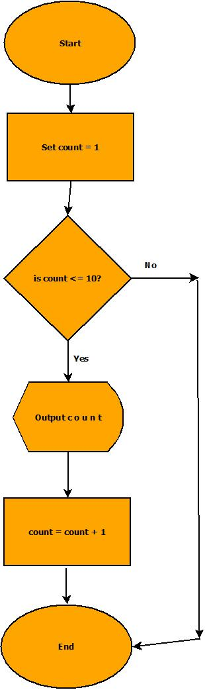
Practice 1: You try: Write commands for java to output 100 numbers starting with 1 and increasing by 1.

Practice 2: You try: Print your name out to the screen 50 times

Practice 3: You try: Print the numbers from 30 down to -2 to the screen on the same line with a space in between
- Sometimes we don’t know how many times we want to iterate
For example, reading in a data file of unknown size.
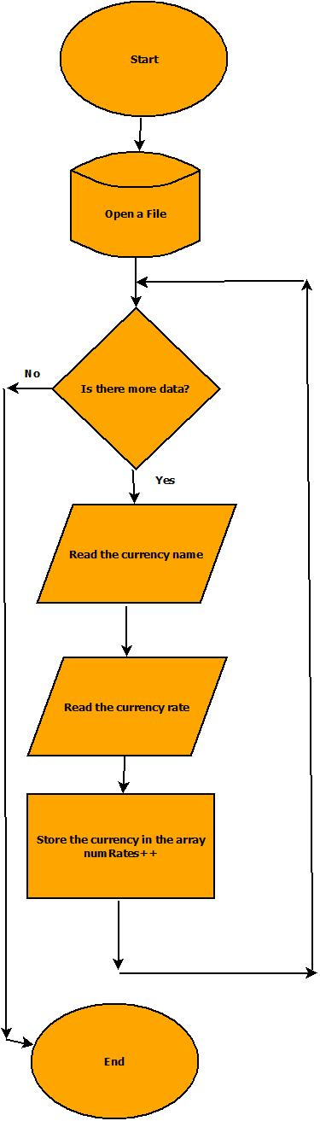 | Must have a file in the project folder called whatever  The variable filename is (example rates.txt)  Euro  .95  Chinese Yuan Renminbi  6.91  Canadian Dollar  1.35  Java:  try {  //Attempt to open the file  File f = new File(fileName);  //Assuming its open, let's grab the currencies  Scanner input = new Scanner(f);  while (input.hasNext()) {  //Read the currency  String descript;  descript = input.nextLine();  String temp = input.nextLine();  double convertRate = Double.parseDouble(temp);  //Now create a new Currency object  Currency c = new Currency(descript, convertRate);  //Add into the array  if (numRates < 100) {  rates[numRates] = c;  numRates++;  }  }  input.close();  }  catch (Exception e) {  System.out.println(" ----------------");  System.out.println("| FILE problem |");  System.out.println(" ----------------");  System.out.println(e); //print the excepti  }

Practice 3: You try: Ask the user for a number. Print all the even numbers from 0 up til and including that number

Scanner input = new Scanner(System.in); //Create a Scanner to read user input

You can also cause the loop to count up by a different number or count down if you like

int i = 0;
while(i<20) {
System.out.println(“ i = “ + i);
i = i + 5;
}
will print
i = 0
i = 5
i = 10
i = 15

Practice 4: you try:
Print the numbers 1,8,15,22,29 with an empty space in between them using a while loop

- Using the break command
The break command ________________________________________________

Using the break command to exit a menu

while (true) {
System.out.println("$$$$$$$$$$$$$$$$$$$$$$$$$$$$$$$$$$$$$$$$");
System.out.println(" TO U S $ F R O M ");
System.out.println();
System.out.println(“\u001B[31m”); //This is red, see the cookbook
System.out.println(" 1 = Euros");
System.out.println(“\u001B[34m”); //This is blue, see the cookbook
System.out.println(" 2 = GB Pounds");
System.out.println(“\u001B[36m”); //This is cyan, see the cookbook
System.out.println(" 3 = Japanese Yen");
System.out.println(“\u001B[33m”); //This is yellow, see the cookbook
System.out.println(" 4 = Chinese Yuan Renminbi");
System.out.println(“\u001B[35m”); //This is purple, see the cookbook
System.out.println(" 5 = Mexican Pesos");
System.out.println(“\u001B[32m"”); //This is green, see the cookbook
System.out.println(“\u001B[0m"); //Resets console back to orig color
System.out.println();
System.out.println(" 0 = BACK TO MAIN");
System.out.println("$$$$$$$$$$$$$$$$$$$$$$$$$$$$$$$$$$$$$$$$");
System.out.println("Enter Choice ->");
char ch = input.next();
if (ch.charAt(0).==(‘0') {
break;
}
} //end while
- Using counters and accumulators
An accumulator:
A counter:

Practice 5: Redo project AlgoPract1_2, the free throw problem. Alter the problem so that the user can type in any number of free throw results and get the % made. Use –1 as a sentinel.

Scanner input = new Scanner(System.in); //Create a Scanner to read user input

- Nested Loops
By nesting one loop inside another, you can accomplish much

int i = 0;
while (i <= 4){
System.out.println(“ i = “ + i);
int j = 0;
while (j < 3){
System.out.println(“ j = “ + j);
j++;
}
i++;
}
will print(fill in the blanks)
i = 0
j = 0
j = 1
j = 2
i = 1
j = 0
j =
j =
i = 2
j = 0
j =
j = 2
i =
j = 0
j = 1
j = 2
i =
j =
j =
j =
Practice 6: you try Use nested loops to draw the following image
****
****
****

Practice 7: you try Use nested loops to make the following image
^^^^
****
^^^^
****
^^^^
****

Practice 8: you try Print a scalable box as follows;
1
&
2
&&
&&
3
&&&
& &
&&&
4
&&&&
& &
& &
&&&&
Practice 9: Displaying a maze the user can see in 2 dimensions
If we want to display a 2d maze on the console, we can use nested loops
Example
int [] [] maze = new int [10][10]; //creates a 2d array of 100 integers, 0 is default value
final int WALL = 1;
final int DOOR = 2;
//Place some walls and doors to make this picture
 | 0 | 1 | 2 | 3 | 4 | 5 | 6 | 7 | 8 | 9
0 | 0 | 0 | 0 | 0 | 0 | 0 | 0 | 0 | 0 | 0
1 | 0 | 0 | 0 | 0 | 0 | 0 | 0 | 0 | 0 | 0
2 | 0 | 0 | 0 | 1 | 1 | 1 | 0 | 0 | 0 | 0
3 | 0 | 0 | 0 | 1 | 0 | 2 | 0 | 0 | 0 | 0
4 | 0 | 0 | 0 | 1 | 0 | 1 | 0 | 0 | 0 | 0
5 | 0 | 0 | 0 | 1 | 1 | 1 | 0 | 0 | 0 | 0
6 | 0 | 0 | 0 | 0 | 0 | 0 | 0 | 0 | 0 | 0
7 | 0 | 0 | 0 | 0 | 0 | 0 | 0 | 0 | 0 | 0
8 | 0 | 0 | 0 | 0 | 0 | 0 | 0 | 0 | 0 | 0
9 | 0 | 0 | 0 | 0 | 0 | 0 | 0 | 0 | 0 | 0
//Do the commands here to place walls

How can we display the maze contents to the screen?

- The precious for loop
One of the authors of the C programming language (Kernigan or Ritchie (no, not Lionel Ritchie)) created a succinct version of the while loop known as the for loop

for (initializer statements; control expression; step expression)
{
body of loop
}
Since everything is on one line, this is simply a delicious command!

To print the first 10 positive integers(beginning with 1) to the screen, use
for(int i=1; i<11; i++)
{
System.out.println(i);
}
You can also leave any of the parts blank or put multiple statements in the first and third separated by ,

Practice 10: you try Write a for loop to print out the numbers from 0 to 1000, every 10 numbers print out a *

Practice 11: you try Write a for loop that will print first 50 powers of 2, ie
1
2
4
8
16
32
…

