Java Lesson: Looping
Last Updated: 12/11/2020
mr Hanley FILLED OUT

Objective: The objective of this lesson is to introduce the student to the java commands for looping to accomplish a particular algorithm.
We are often finding ourselves defining algorithms where a certain set of steps is repeated over and over again. This is known in computer science as iteration
Various commands are available
the for loop, the do..while loop and the while loop are typical in programming languages.
Perhaps we want to read in free throw results from a user and compute the ft %. Or maybe we want to print out the headings for a calendar.

Contents
- Looping a fixed number of times
- Looping an unknown number of times
- Using the break command
- Using counters and accumulators
- Nested Loops
- The precious for loop

- Fixed number of iterations
Suppose we want to repeat a command a definite number of times
Example 1: Printing 10 integers to the console starting at 1
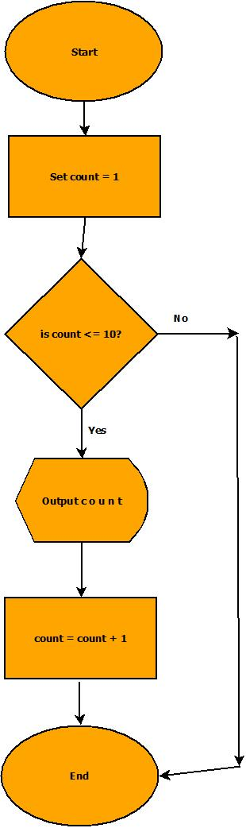 | int i = 1;//loop control  while(i <= 10) {  System.out.println(i);  i = i + 1;  }
Practice 1: You try: Write commands for java to output 100 numbers starting with 1 and increasing by 1.
int i = 1;//loop control
while(i <= 100) {
System.out.println(i);
i = i + 1;
}

Practice 2: You try: Print your name out to the screen 50 times
int i = 1;//loop control
while(i <= 50) {
System.out.println(“Tom Anderson”);
i = i + 1;
}

Practice 3: You try: Print the numbers from 30 down to -2 to the screen on the same line with a space in between
int i = 30;//loop control
while(i >= -2) {
System.out.print(i+” “);
i = i - 1;
}

- Sometimes we don’t know how many times we want to iterate
For example, reading in a data file of unknown size.
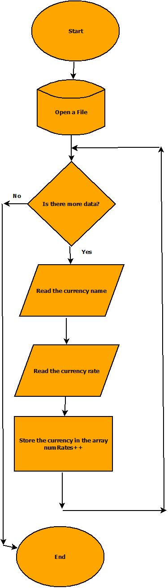 | Must have a file in the project folder called whatever  The variable filename is (example rates.txt)  Euro  .95  Chinese Yuan Renminbi  6.91  Canadian Dollar  1.35  Java:  try {  //Attempt to open the file  File f = new File(fileName);  //Assuming its open, let's grab the currencies  Scanner input = new Scanner(f);  while (input.hasNext()) {  //Read the currency  String descript;  descript = input.nextLine();  String temp = input.nextLine();  double convertRate = Double.parseDouble(temp);  //Now create a new Currency object  Currency c = new Currency(descript, convertRate);  //Add into the array  if (numRates < 100) {  rates[numRates] = c;  numRates++;  }  }  input.close();  }  catch (Exception e) {  System.out.println(" ----------------");  System.out.println("| FILE problem |");  System.out.println(" ----------------");  System.out.println(e); //print the excepti  }

Practice 4: You try: Ask the user for a number. Print all the even numbers from 0 up til and including that number

Scanner input = new Scanner(System.in); //Create a Scanner to read user input
int limit, i;
sout(“enter limit”);
limit = input.nextInt();
i = 0;
while(i <= limit) {
System.out.println(i);
i = i + 2;
}
You can also cause the loop to count up by a different number or count down if you like
int i = 0;
while(i<20) {
System.out.println(“ i = “ + i);
i = i + 5;
}
will print
i = 0
i = 5
i = 10
i = 15
Practice 5: you try:
Print the numbers 1,8,15,22,29 with an empty space in between them using a while loop
int i = 1;//loop control
while(i<=29) {
System.out.print(i+” “);
i = i +7;
}

- Using the break command
The break command terminates nearest loop

Using the break command to exit a menu

while (true) {
System.out.println("$$$$$$$$$$$$$$$$$$$$$$$$$$$$$$$$$$$$$$$$");
System.out.println(" TO U S $ F R O M ");
System.out.println();
System.out.println(“\u001B[31m”); //This is red, see the cookbook
System.out.println(" 1 = Euros");
System.out.println(“\u001B[34m”); //This is blue, see the cookbook
System.out.println(" 2 = GB Pounds");
System.out.println(“\u001B[36m”); //This is cyan, see the cookbook
System.out.println(" 3 = Japanese Yen");
System.out.println(“\u001B[33m”); //This is yellow, see the cookbook
System.out.println(" 4 = Chinese Yuan Renminbi");
System.out.println(“\u001B[35m”); //This is purple, see the cookbook
System.out.println(" 5 = Mexican Pesos");
System.out.println(“\u001B[32m"”); //This is green, see the cookbook
System.out.println(“\u001B[0m"); //Resets console back to orig color
System.out.println();
System.out.println(" 0 = BACK TO MAIN");
System.out.println("$$$$$$$$$$$$$$$$$$$$$$$$$$$$$$$$$$$$$$$$");
System.out.println("Enter Choice ->");
char ch = input.next();
if (ch.charAt(0).==(‘0') {
break;
}
} //end while
- Using counters and accumulators
An accumulator: variable that accumulates over time
A counter: var that counts up by one

Practice 6: Redo project AlgoPract1_2, the free throw problem. Alter the problem so that the user can type in any number of free throw results and get the % made. Use –1 as a sentinel.

Scanner input = new Scanner(System.in); //Create a Scanner to read user input
double sum, count;
int result;
sum = count = 0;
while(true) {
System.out.println(“Enter 1, 0 or -1”);
result = input.nextInt();
if(result == -1) {
break;
}
if(result == 0){
count++;
}
if(result == 1){
sum++; //one more ft is made
count++;
}
}
double avg = sum/count * 100;
System.out.println(avg);

- Nested Loops
By nesting one loop inside another, you can accomplish much

int i = 0;
while (i <= 4){
System.out.println(“ i = “ + i);
int j = 0;
while (j < 3){
System.out.println(“ j = “ + j);
j++;
}
i++;
}
will print(fill in the blanks)
i = 0
j = 0
j = 1
j = 2
i = 1
j = 0
j =
j =
i = 2
j = 0
j =
j = 2
i =
j = 0
j = 1
j = 2
i =
j =
j =
j =
Practice 7: you try Use nested loops to draw the following image
****
****
****

//rows
int r = 0;
while(r < 3) {
int c = 0; //cols
while(c < 4) {
System.out.print(“*”);
c++;
}
System.out.println();//drop down
r++;
}
Practice 8: you try Use nested loops to make the following image
^^^^
****
^^^^
****
^^^^
****
//rows=6
//cols=4
int r = 0;
while(r < 6){
int c = 0;
while (c < 4) {
if (r % 2 == 0){ //even
System.out.print(“*”);
}
else{ //odd
System.out.print(“^”);
}
c++;
} //inner loop
r++;
System.out.println();
} //outer loop

Practice 9: you try Print a scalable box as follows;
1
&
2
&&
&&
3
&&&
& &
&&&
4
&&&&
& &
& &
&&&&
Scanner input = new Scanner(System.in);
System.out.println(“Please enter size”);
int size = input.nextInt();

int r = 0;
while(r < size){ //loop for rows according
//to size
int c = 0;
while (c < size) {
if (r == 0 || r == size-1 || c == 0
||c == size-1 ){ //outside
System.out.print(“&”);
}
else{ //inside
System.out.print(“ ”);
}
c++;
} //inner loop
r++;
System.out.println();
} //outer loop
Practice 10: Displaying a maze the user can see in 2 dimensions
If we want to display a 2d maze on the console, we can use nested loops
Example
int [] [] maze = new int [10][10]; //creates a 2d array of 100 integers, 0 is default value
final int WALL = 1;
final int DOOR = 2;
//Place some walls and doors to make this picture
 | 0 | 1 | 2 | 3 | 4 | 5 | 6 | 7 | 8 | 9
0 | 0 | 0 | 0 | 0 | 0 | 0 | 0 | 0 | 0 | 0
1 | 0 | 0 | 0 | 0 | 0 | 0 | 0 | 0 | 0 | 0
2 | 0 | 0 | 0 | 1 | 1 | 1 | 0 | 0 | 0 | 0
3 | 0 | 0 | 0 | 1 | 0 | 2 | 0 | 0 | 0 | 0
4 | 0 | 0 | 0 | 1 | 0 | 1 | 0 | 0 | 0 | 0
5 | 0 | 0 | 0 | 1 | 1 | 1 | 0 | 0 | 0 | 0
6 | 0 | 0 | 0 | 0 | 0 | 0 | 0 | 0 | 0 | 0
7 | 0 | 0 | 0 | 0 | 0 | 0 | 0 | 0 | 0 | 0
8 | 0 | 0 | 0 | 0 | 0 | 0 | 0 | 0 | 0 | 0
9 | 0 | 0 | 0 | 0 | 0 | 0 | 0 | 0 | 0 | 0
//Do the commands here to place walls
maze[2][3]=WALL; maze[2][4]=WALL; maze[2][5]=WALL; maze[2][6]=DOOR;
maze[3][3]=WALL; maze[4][3]=WALL;

How can we display the maze contents to the screen?

int r=0;
while(r<10){
int c=0;
while(c<10){
System.out.print(maze[r][c]);
c++;
}
r++;
System.out.println();
}
The precious for loop

for (initializer statements; control expression; step expression)
{
body of loop
}
Since everything is on one line, this is simply a delicious command!

To print the first 10 positive integers(beginning with 1) to the screen, use
for(int i=1; i<11; i++)
{
System.out.println(i);
}
You can also leave any of the parts blank or put multiple statements in the first and third separated by ,

Practice 11: you try Write a for loop to print out the numbers from 0 to 1000, every 10 numbers print out a *

for(int i =1; i<=1000; i++){
System.out.println(i);
if(i%10==0) {
System.out.println(“*”);
}
}

Practice 12: you try Write a for loop that will print first 50 powers of 2, ie
1
2
4
8
16
32
…

for(long i=1,sum=1; i<=50; i++){
System.out.println(sum);
sum = sum * 2;
}

OR

for(int p=0, p<50; p++){
System.out.println(Math.pow(2,p));
}

