Java Lesson: Selection Statements
Last Updated: 2/12/2017
mr Hanley

Objective: The objective of this lesson is to introduce the student to the java commands for choosing between different blocks of code, notably the if statement as well as the relational and logical operators.
Every computer programming language has the ability to select between different patways of logic.
Java offers the one way if and two way if…else selection statements in addition to the switch case multiway statement.
Consider the following flowchart:
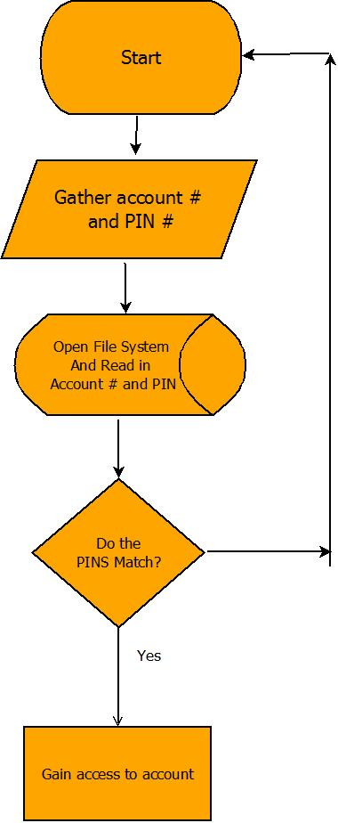
What does this flowchart model?
ATM bank access
The if statement
Allows conditional code based on expression
if( condition ) {
//logic
}
logic only runs when condition is true
Example1: Assuming you are in a java program with a Scanner object called input created, declare a variable called fTemp (float) and read in the variable from the keyboard. Tell the user via SOPln whether or not the temperature is below freezing.
float fTemp;
System.out.println(“Enter number”);
fTemp=input.nextFloat();
if(fTemp <= 32) {
System.out.println(“Freezing”);
}

The if..else statement
2 way selection. If first part false, second block is executed.
if( ) {
//code
}
else {
//code 2
}
Example 2: Assuming you are in a java program with a Scanner object called input created, declare a variable called num (short) and read in the variable from the keyboard. Tell the user via SOPln whether the number is gt 10 or less then or equal to 10.
short num;
System.out.println(“Enter number”);
num=input.nextShort();
if(num > 10) {
System.out.println(“Gt 10”);
}
else {
System.out.println(“Lte 10”);
}

Example3: When do you need curly braces, what gets printed by the following code fragment?
int cost = 15, given = 18;
if(given >= cost)
System.out.println(“Transaction approved!”);
if(given < cost)
System.out.println(“Insufficient Funds”);
System.out.println(“There is a problem”);
Output:
Transaction Approved
There is a problem
Conclusion:Because there were no {} used, only ONE statement is considered part of the second if block. Therefore, always use { when putting more than one statement inside an if or else block. INDENTATION does not matter in java
The relational operators:
< less than, > greater than, <= less than or equal to, >= greater than or equal to, != not equal to, == equal to
The logical operators:
&& And Both conditions must be true
|| Or At least one condition must be true
! Not Takes opposite

Example4:
double gpa = <some value>
boolean hasInfraction = <true if have received a referral for poor behavior>
int numberTardies = <some value for the number of times late to school>
Write an expression for senior_priv which is true if the student has a 85 or greater, has no infractions and has been tardy at most 3 times
boolean senior_priv = gpa >= 85 && !hasInfraction && numTardies <=3;
Reading in and testing Strings:
Strings must be read with either next() or nextLine()
next() captures Strings with NO SPACES
nextLine() allows Strings with spaces
String name = input.next();
or String fullName = input.nextLine();

Example 5: Assigning a letter grade. Read in a number from the keyboard, print out either A, B, C, D or F.
int grade = input.nextInt();
if(grade >= 90) {
System.out.println(“A”);
} else if(grade >=80) {
System.out.println(“B”);
} else if(grade >=70) {
System.out.println(“C”);
} else if(grade >=65) {
System.out.println(“D”);
} else {
System.out.println(“F”);
}

Nested if statements: Placing one if statement inside of another
if ( ){
if( ) { //can test for multiple conditions

Example 6: Read an integer from the keyboard, tell whether it is divisible by 9 and 4, 9 but not 4, 4 but not 9 or neither 9 or 4.
Using Nested Ifs | Using Logical Operators
int num = input.nextInt();  //test for 9  if(num % 9 == 0) {  //Test for 4 divisibility  if(num%4 == 0) {  System.out.println(“Both”);  }  else {  System.out.println(“9 not 4”);  }  }  else { //not 9  //Test for 4 divisibility  if(num%4 == 0) {  System.out.println(“4 not 9”);  }  else {  System.out.println(“neither”);  }  } | int num = input.nextInt();  if(num % 9 == 0 && num % 4 == 0){  System.out.println(“Both”);  }  if(num % 9 != 0 && num % 4 == 0){  System.out.println(“4 only”);  }  if(num % 9 == 0 && num % 4 != 0){  System.out.println(“9 only”);  }  if(num % 9 != 0 && num % 4 != 0){  System.out.println(“Neither”);  }

